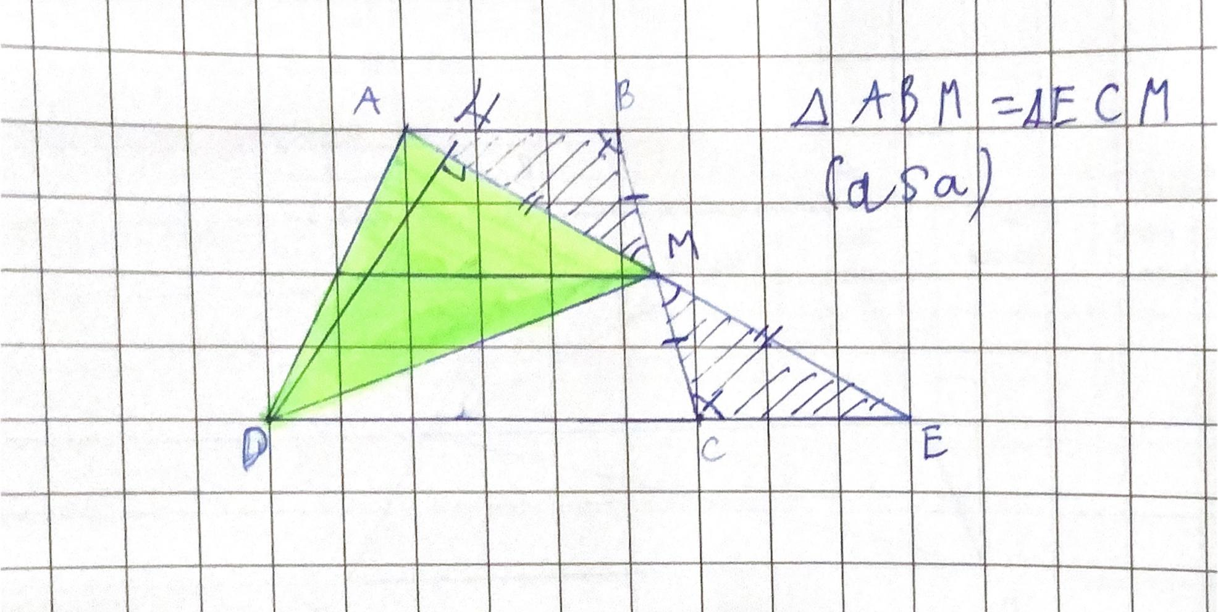
To basically explain if the green shaded shape (ADM) is half of the trapezium, now lets make them into letters:
- ADM
- ABM
- MCE
- ADE
With all of these shapes we will be able to explain the whole solution faster and easier.
We also need another triangle (the MCE) to replicate the trapezium and the shape ABM. This is also to make it look way easier for people to know.
you will have to make another triangle (MCE) that is equal to (ABM). The shaded (ADM) shape is half of the whole shape of ADE because example you calculate the area ABCD and ADE, they will be equal to prove that DME and ADM will be equal to eachother and DMC + ABM is the same to ADM

