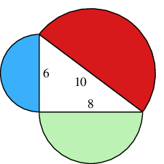
The Quintessential Proof:
1. How are the Areas of the following semicircles related?
The following semicircles are related through the formula $A=0.5πr^{2}$ (half of that for the area of a circle), where the radius is half that of the value given for that of the sides. Since this is a right angled triangle, it can also be said that the areas are related through Pythagoras’ theorem which states that the sum of two (non hypotenuse) sides of a triangle are equal to the square of the hypotenuse. As an example it can therefore be said that the area of the red semicircle is equal to $0.5π×{(x}^{2}+y^{2})$ where x and y are the values for the lengths of the other sides. It is therefore evident that the areas of each semicircle are related.
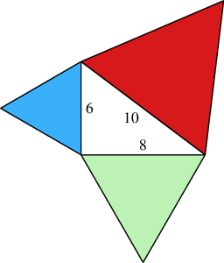
2. How are the areas of the following equilateral triangles related.
The areas of the following triangles are related through the formula $A=0.5bh$ where the height is $\sqrt{b^{2}-{(0.5b)}^{2}}$, as determined through the use of Pythagoras’ theorem applied to a half of one of the original triangles. It can also be said that the sides of the triangle are related by Pythagoras’ theorem, which states that the sum of two (non hypotenuse) sides of a triangle are equal to the square of the hypotenuse. As a result it can be said that the area of the red triangle is equal to $A=0.5\sqrt{a^{2}+b^{2}}×\sqrt{{(\sqrt{a^{2}+b^{2}})}^{2}-{(0.5×\sqrt{a^{2}+b^{2}})}^{2}}$ where the values of a and b are equal to the other sides of the inner, right angled triangle, therefore proving that the areas of each of the equilateral triangles are related to one another.
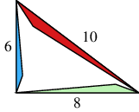
How are the areas of the following similar triangles related:
The following similar triangles are related through the formula $A=0.5bh$, where the base is given for each triangle, however the height is not given. It can however be assumed that the height of each is proportional to the given side (base), since they are similar triangles. As a result the height could also be written as $\frac{b}{6}x$ where the values of x is the value for the height of the smallest triangle (which we do not know). As well as this it could also be said that the triangles are related through Pythagoras’ theorem which states that the sum of two (non hypotenuse) sides of a triangle are equal to the square of the hypotenuse. It can therefore be said that the lengths of each side are related through the formula $h=\sqrt{a^{2}+b^{2}}$, where h is the hypotenuse of the original, right angled triangle and a and b are the remaining sides. As a result the value of the areas of the triangles, being based on the length of these sides, can also be said to be related. As an example the area of the red triangle could be written as $A=0.5\sqrt{a^{2}+b^{2}}×\frac{\sqrt{a^{2}+b^{2}}}{6}x$ or with actual values substituted in, as $A=0.5\sqrt{6^{2}+8^{2}}×\frac{\sqrt{6+8^{2}}}{6}x$. This value cannot however be determined because we do not know the value for x.
The Proof of Pythagoras’ theorem:
How are the areas of the two smaller triangles (to the left) related to the area of the one larger one (on the right).
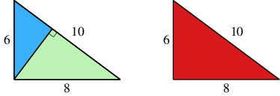

Since the area of a triangle is equal to $A=0.5bh$ and in each of the following, the sum of the two smaller triangles produce values for b (8) and h (6), it can be said that the areas are equal, and therefore that the sum of the area of the two smaller triangles is equal to the area of the larger one.
This can be proven as follows:
$$A_{Total}=0.5×6×8=24 {units}^{2}$$
Values on the triangle can be given as follows, for calculation purposes;
x

h
10-x

$$A_{Total}=A_{green}+A_{blue}$$
$$A_{Total}=\left(0.5\left(10-x\right)h\right)+(0.5xh)$$
$$A_{Total}=5h-0.5xh+0.5xh$$
$$A_{Total}=5h=24$$
$$h=4.8$$
From this, the area of the sum of the two smaller triangles can be determined using the value of h, and compared with the value for the area of the larger (single) triangle to determine whether or not the conjecture that the sum of the area of the two smaller triangles, is in fact equal to that of the larger triangle. This is done as follows.
$$A_{g+b}=0.5bh=0.5×10×4.8$$
$$A_{g+b}=24$$
$$A_{r}=0.5×8×6=24$$
$$A_{g+b}=A_{r}$$
This proves that the area of the larger triangle is equal to the sum of the area of the two smaller triangles.
How does this prove Pythagoras’ Theorem?
From this it can be determined that the area of each of the triangles are related, in that the area of the larger triangle is equal to the sum of the two smaller ones, and therefore given some extra information it can be used to prove Pythagoras theorem.

As shown in the above diagram each of the 3 triangles are similar, as they have angles of the same magnitude. From this it can be determined that each side of the 2 smaller triangles is related to a side of the larger triangle by an unknown factor (in this case referred to as either n or m). This is shown below. In the below example ignore any numerical values and instead refer to the assigned constants.

A
C

B

From here, the unknown sides can be assigned values of a, b or c (multiplied by the unknown constants n or m), depending upon their position in relation to the original (large) triangle. This has been done below:
ma
C
Na=mb
A=mc
nb
B=nc

As proven in the previous section, the area of the sum of the two smaller triangles is equal to that of the larger one. This concept has been used in the following proof.

$$A=0.5bh$$
$$A=0.5AB$$
Or written using factors of side C:
$$A=0.5×nc×mc$$
$$A=0.5nmc^{2}$$
As proven in the above section the area can also be determined by calculating the sum of the two smaller triangles. This is shown below:
$$A=\left(0.5×na×ma\right)+\left(0.5×nb×mb\right)$$
$$A=0.5{nma}^{2}+0.5nmb^{2}$$
It can therefore be said that:
$$0.5nmc^{2}=0.5nma^{2}+0.5nmb^{2}$$
Or simplified
$$c^{2}=a^{2}+b^{2}$$
This therefore proves Pythagoras’ theorem, which states that the sum of two (non hypotenuse) sides of a triangle are equal to the square of the hypotenuse.

