Maths Investigation: Circular Arguments

This series of problems (http://nrich.maths.org/11474) investigates the properties associated with triangular and circular geometry in a Cartesian coordinate system method of representation. Divided into 4 parts, each section focuses on a particular proof, theorem or idea associated with fundamental geometric ideas used in many different areas of mathematics.

- The Quintessential Proof – outlining the problem
- This problem investigates basic elements of the Pythagorean proof and attempts to prove it through algebra. While in lower school, Pythagorean proof is established visually with the use of squares and similar triangles; this problem is further extended by the requirement of Pythagoras’ theorem as not being self-evident.

~

The Quintessential Proof:
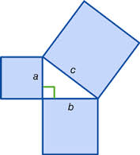
When first introduced to the idea of Pythagoras’ theorem, it is often done so as showing a right-angled triangle with three squares on either side (see example 1 below). Basic algebra is used to show that the square of the hypotenuse is equal to the sum of the two smaller side’s squares. However, this is commonly done with given side lengths; a proof that isn’t valid for variable/unknown side lengths.
Example 1

Thus to show that this proof is valid for generic, unknown side-lengths, this question is scaffolded to show that for any three similar 2D shapes that can be arranged to form a right angled triangle, the sum of the two smaller shapes area is equal to the area of the larger shape. Thus:

- “Show how the areas of these three semicircles are related.”
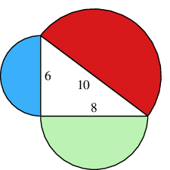
We know that the area of a sector is equal to;
$$A=πr^{2}×\frac{θ}{360}$$
Where A = the area of the sector
r = distance from the centre to the circumference
(in this example, the numbers represent the diameter so the ‘r’ value is half the diameter (radius)
θ = the angle at the centre of curvature subtended by two points on the sector
A semicircle is a special case in this scenario as the angle subtended forms a straight line and therefore has an angle of 180°.
Thus, the area of a semicircle is;
$$A=\frac{πr^{2}}{2}$$
If we represent the area of each semicircle as A(r), then it is easy to see how
A(3) + A(4) = A(5).
A(3) = $\frac{π3^{2}}{2}$ = 4.5π A(4) = $\frac{π4^{2}}{2}$ = 8π A(5) =$\frac{π5^{2}}{2}$ = 12.5π

4.5π + 8π = 12.5π.
Thus, it can be seen that this is valid for semicircles.
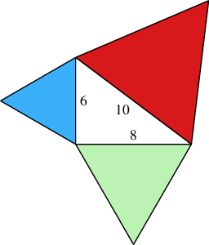
- “Show how the areas of these three equilateral . triangles are the same”

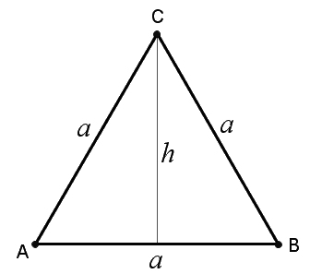
The area of any triangle can be found by multiplying the length of the base by the perpendicular height.
In an equilateral triangle, the height can be found using Pythagoras theorem (for the first section of this problem, Pythagoras theorem can be used as part of the proof).
Thus, in the diagram on the right, the height, h can be found by;
$$h=\sqrt{a^{2}-({\frac{a}{2})}^{2}}$$
(It is a given that h is a perpendicular bisector of line AB so that a right angle is formed)
Therefore, the area of an equilateral triangle is found by:
$$B=\frac{a}{2}×\sqrt{a^{2}-({\frac{a}{2})}^{2}}$$
Where: B = area of the triangle
a = side length of triangle

Therefore, if we represent the area of each equilateral triangle by B(a), then it can be shown that B(6) + B(8) = B(10):

B(6) = $\frac{6 }{2}×\sqrt{6^{2}-({\frac{6}{2})}^{2}}$ = $3× \sqrt{36-9}$ = $3\sqrt{27}$ = 15.588

B(8) =$\frac{8 }{2}×\sqrt{8^{2}-({\frac{8}{2})}^{2}}$ = $4× \sqrt{64-16}$ = 4$\sqrt{48}$ = 27.713

B(10) = $\frac{10 }{2}×\sqrt{{10}^{2}-({\frac{10}{2})}^{2}}$ = $5× \sqrt{100-35}$ = 5$\sqrt{75}$ = 43.301

15.588 + 27.713 = 43.301
∴B(6) + B(8) = B(10)

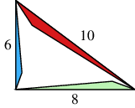
- “Show how the areas of these three similar . triangles are related”
A
C
B
D
F
E
Example 2
5
3
252
h₁
The property that makes similar triangles special is the relationship between larger and smaller versions. The ratio of one side length to a corresponding side length in a similar triangle is a constant.
This constant is the same between each corresponding side length and resultantly means that the perpendicular height is in a ratio between similar triangles.

Using Example 2, we can see that
Line FD = $λ×$Line CA (λ represents the scalar multiple
used to determine the ratio)
∴5 = 25λ
λ = 0.2
We also know that:
sin(∠FED) = 3/5
Because ∠BAC corresponds to ∠FED,
sin(∠BAC) = 3/5

∴3/5 = h₁/25
∴ h₁= 15

Then, to prove that the perpendicular height is in a ratio:
3 = h₁λ
3 = 15 * λ
λ = 0.2
∴the ratio between side lengths is equivalent to the ratio between perpendicular heights in similar triangles.

So, to prove this question,
I will define the area of each similar triangle as C(b) (where b is the length of the hypotenuse)
C(b) = $\frac{1}{2}bh$

C(6) = $\frac{1}{2}×6×h$ = 3h = $\frac{9}{3}h$

C(8) = $\frac{1}{2}×8×\left(\frac{8}{6}h\right)$ = $\frac{16}{3}h$

C(10) = $\frac{1}{2}×10×(\frac{10}{6}h)$ = $\frac{25}{3}h$

$\frac{9}{3}h$ + $\frac{16}{3}h$ = $\frac{25}{3}h$

∴C(6) + C(8) = C(10)

“Proving Pythagoras’ Theorem”
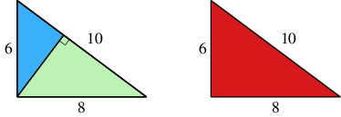
The final part of the question involves proving Pythagoras theorem without assuming it to be true.
The only hint given in the question is to drawing a perpendicular to intersect with the hypotenuse. (see diagram on left)

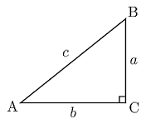
The following is how I solved the solution:
d
e
f
D
(Note, in the diagram, capitals refer to a vertex, lower case refers to a side length, AB = c = d + e)

∠BDC = ∠BCA (Right angles)
∠DBC = ∠CBA (Same angles)
∴ ΔBDC ∼ ΔBCA (AAA)

∠CDA = ∠BCA (Right angles)
∠DAC = ∠CAB (Same angles)
∴ ΔCDA ∼ ΔBCA (AAA)

From the similar triangle properties;
$\frac{d}{a}= \frac{a}{c}$ $\frac{e}{b}= \frac{b}{c}$

∴a² = cd ∴b² = ce

∴a² + b² = cd + ce
∴a² + b² = c(d+e)
However, we know that side length c = d+e
∴a² + b² = c²

