4. The Circle of Apollonius (+ errors and initial steps)
Two fixed points A and B lie in the plane, and the distance between them is AB = 2a, where a > 0.
A point P moves in the plane so that the ratio of its distances from A and B is constant:
$$\frac{PA}{PB}=λ$$
where λ > 0.
4.1 Can you sketch the locus of the point P for different values of λ?
I used the suggested values as given on the website to start this investigation.
Assume a=2 and λ=3 and Let P₁ (x₁,y₁), A(0,2) and B(0,-2)

$\left\{\begin{aligned}\frac{PA}{PB}=3 \\ PA+PB=4\end{aligned}\right\} PA=3, PB=1$ ∴ P₀ (0,-1)

After finding the initial point where P would lie (P₁) I thought I would assume a value for x₂ in-order to work out the next y-value (a method we used previously in specialist)
Let P₂(x₂,y₂) where x₂ = 2

$$\frac{\sqrt{{\left(2-0\right)}^{2}+{(y-2)}^{2}}}{\sqrt{{\left(2-0\right)}^{2}+{(y+2)}^{2}}}=3$$

$\sqrt{{\left(2-0\right)}^{2}+{(y-2)}^{2}}=3\sqrt{{\left(2-0\right)}^{2}+{(y+2)}^{2}}$
This ended up giving this equation which gave no solution, initially not knowing why it wouldn’t we tried to fix this. I didn’t know what was wrong before I realised that without an x in the equation, only a y value could be given, as well as later finding out that using an x value of 2 was outside the given domain and thus would not give a solution. So instead we didn’t assume a value for x₂, and rewrote it as:
$\sqrt{{\left(x-0\right)}^{2}+{(y-2)}^{2}}=3\sqrt{{\left(x-0\right)}^{2}+{(y+2)}^{2}}$
Which fixed the problem as we left x as a variable.
This gave us a circle which looked like this:

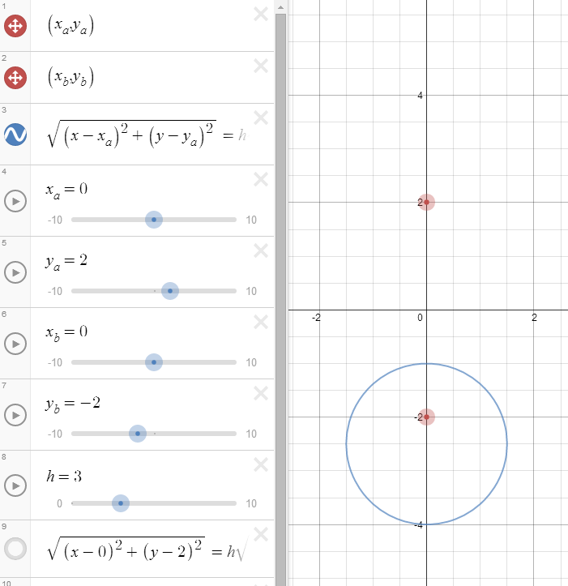
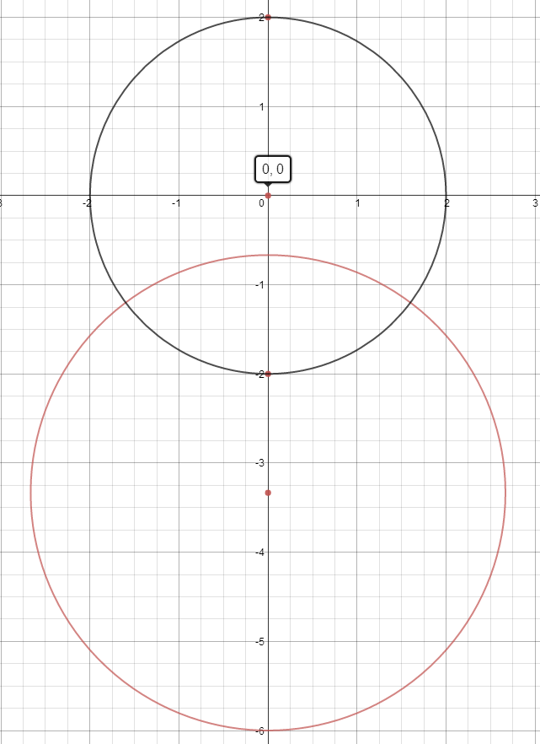$λ=2$ 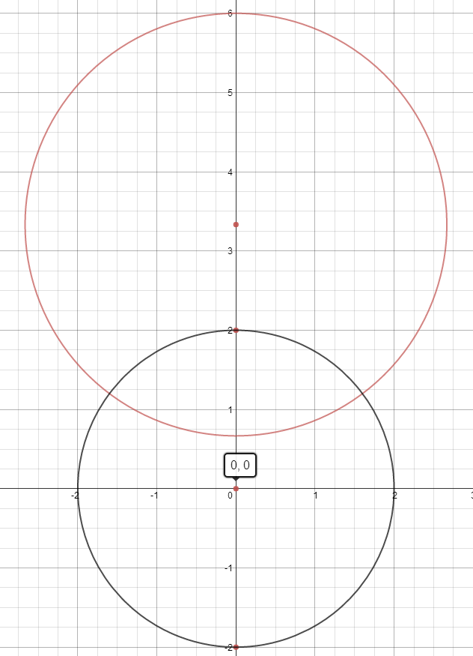$λ=0.5$

Since Desmos allows the use of sliders, instead of only using the value of λ to be equal to 3, we added a variable ‘h’ where λ would be, so we could see the effects of lambda.

4.2 Using Cartesian coordinates, work out (the equation of) the locus of P.

After the work above, I figured out a generalised equation for the locus of P with the help of Mr Prideaux, which is: (general equation ${(x-a)}^{2}+{\left(y-b\right)}^{2}=r^{2}$)

$$\sqrt{{\left(x-x_{a}\right)}^{2}+{(y-y_{a})}^{2}}=λ \sqrt{{\left(x-x_{b}\right)}^{2}+{(y+y_{b})}^{2}}$$
Initially this is where I left it, however after the guidance of Mr Prideaux, he guided us into making the equation so that it is similar to the general equation of a circle. ${(x-a)}^{2}+{\left(y-b\right)}^{2}=r^{2}$

$${\left(x-x_{a}\right)}^{2}+{\left(y-y_{a}\right)}^{2}=λ^{2}\left[{\left(x-x_{b}\right)}^{2}+{\left(y+y_{b}\right)}^{2}\right]$$

$$x^{2}-2xx_{a}+{x_{a}}^{2}+y^{2}-2yy_{a}+{y_{a}}^{2}-$$
$${λ^{2}x}^{2}+2λ^{2}xx_{b}-{λ^{2}x_{b}}^{2}-{λ^{2}y}^{2}+2λ^{2}yy_{b}-{λ^{2}y_{b}}^{2}=0$$

$$x^{2}\left(1-h^{2}\right)-2x\left(x_{a}-λ^{2}x_{b}\right)+y^{2}\left(1-h^{2}\right)-2y\left(y_{a}{-λ}^{2}y_{b}\right)=$$
$$-{x_{a}}^{2}-{y_{a}}^{2}+{λ^{2}x_{b}}^{2}+{λ^{2}y_{b}}^{2}$$

$$x^{2}-\frac{2x\left(x_{a}-λ^{2}x_{b}\right)}{\left(1-h^{2}\right)}+y^{2}-\frac{2y\left(y_{a}{-λ}^{2}y_{b}\right)}{\left(1-h^{2}\right)}=$$
$$\frac{-{x_{a}}^{2}-{y_{a}}^{2}+{λ^{2}x_{b}}^{2}+{λ^{2}y_{b}}^{2}}{\left(1-h^{2}\right)}$$

Completing the square to form general equation of a circle, i.e
$${(x-a)}^{2}+{\left(y-b\right)}^{2}=r^{2}$$
$${(x-\frac{x_{a}-λ^{2}x_{b}}{1-h^{2}})}^{2}+{(y-\frac{y_{a}{-λ}^{2}y_{b}}{1-h^{2}})}^{2}=$$
$$\frac{-{x_{a}}^{2}-{y_{a}}^{2}+{λ^{2}x_{b}}^{2}+{λ^{2}y_{b}}^{2}}{\left(1-h^{2}\right)}+ {(\frac{x_{a}-λ^{2}x_{b}}{1-h^{2}})}^{2}+{(\frac{y_{a}{-λ}^{2}y_{b}}{1-h^{2}})}^{2}$$

From this we can gather three different things. If we look at the general equation of a circle (In the textbox on the right hand side) we notice the variables ‘a’, ‘b’ and ‘r’. With our new equation we have above, we can therefore find the values of these variables, and since the ‘a’ corresponds to the x value of the centre point and the ‘b’ corresponds to the y value of the centre point, we are able to find the centre of this circle. Also the ‘r’ giving the radius of the circle.

So to find the co-ordinates of the centre of the circle, it is:

$$(\frac{x_{a}-λ^{2}x_{b}}{1-h^{2}}, \frac{y_{a}{-λ}^{2}y_{b}}{1-h^{2}})$$
Where ${(x}_{a},y_{a})$ represents the co-ordinates of point A and ${{(x}_{b}y}_{b})$ represents the co-ordinates of point B, and h represents λ.

$$\frac{-{x_{a}}^{2}-{y_{a}}^{2}+{λ^{2}x_{b}}^{2}+{λ^{2}y_{b}}^{2}}{\left(1-h^{2}\right)}+ {(\frac{x_{a}-λ^{2}x_{b}}{1-h^{2}})}^{2}+{(\frac{y_{a}{-λ}^{2}y_{b}}{1-h^{2}})}^{2}$$

This part of the equation (as shown above) is the expression to find out the radius of this circle ‘r’.

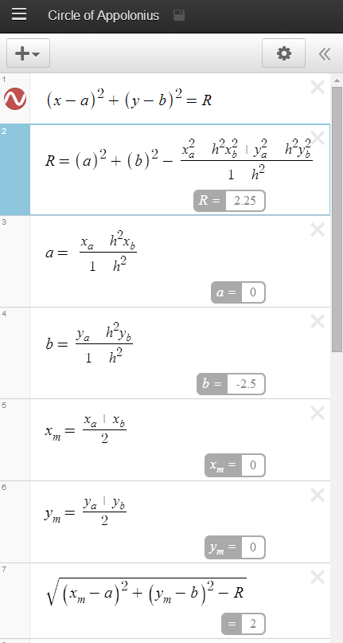
NOTE:
To keep things simple, I have allocated variables to complex expressions and will refer to these variables for ease of explanation

(For some reason my Desmos at home was playing up and so where there is a space, it’s meant to be a subtract symbol (-) and where there is a vertical line, it’s meant to be an addition symbol (+))

R = Radius

a = x co-ordinate of centre
b = y co-ordinate of centre

x_{m} = x co-ordinate of midpoint

y_{m} = y co-ordinate of midpoint

4.3 Now assuming that λ≠1, find the radius and centre of the circle. What is the length of the tangent to this circle from the mid-point of AB? What shape is traced by the tangent as λ varies?

The length of the tangent from the circle to the midpoint of AB can be calculated through the use of Pythagoras’ Theorem. In this case we know that the tangent from the midpoint of AB to the circle, will form a perpendicular with the radius of the circle. Having these two side lengths connected, as well as the line from the midpoint of AB to the centre of the circle, thus forms a triangle with a right angle, which allows us to use Pythagoras’ Theorem to find the length of the tangent.
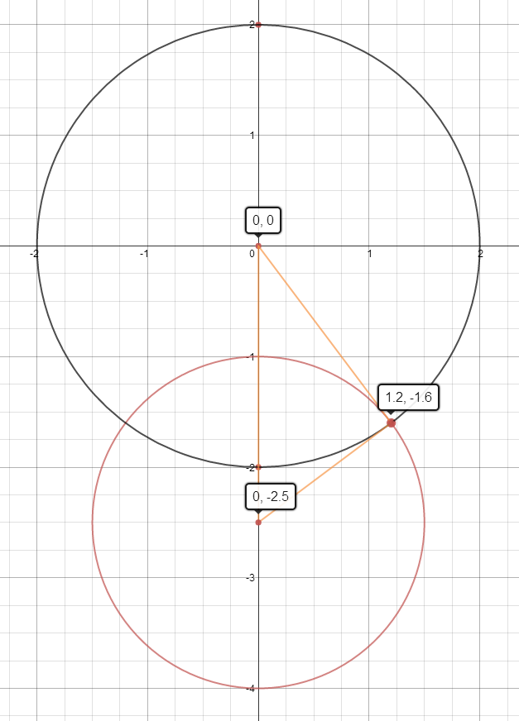
Since we know the length of the hypotenuse (side AB ) and one other side (radius) we can re-arrange Pythagoras’ Theorem to work out one the other side. i.e.

$$a^{2}+b^{2}=c^{2}$$

$$b^{2}=c^{2}-a^{2}$$

$$b=\sqrt{c^{2}-a^{2}}$$

Where a = Radius
b = Tangent
c = Side AB

So for the distance of the radius of the circle, we already have an expression for this, as mentioned earlier in this question, the radius will be referred to as R.

Since a is equal to the radius which is R we can sub this for where we have a in our Pythagoras’ Theorem equation.

For side c or side AB, this is the distance between two points formula, between the midpoint of AB and the centre of the circle, which is expressed as:

$$AB=\sqrt{{(x_{m}-a)}^{2}-{(y_{m}-b)}^{2}}$$
From this if we substitute in the things that we now know, we can find an equation for side length b which is the tangent.
So from:
$$b=\sqrt{c^{2}-a^{2}}$$
We can form:

$$b=\sqrt{{\sqrt{{(x_{m}-a)}^{2}-{(y_{m}-b)}^{2}}}^{2}-R^{2}}$$

$$b=\sqrt{{(x_{m}-a)}^{2}-{(y_{m}-b)}^{2}-R^{2}}$$

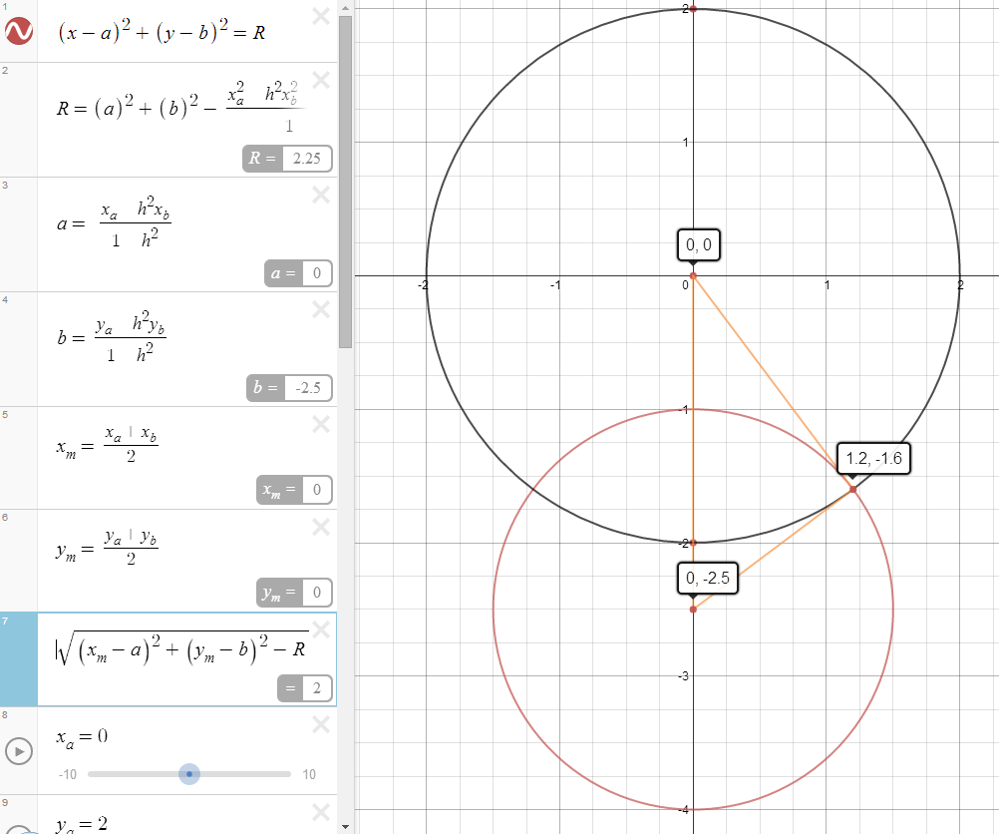

This equation as written exactly the same above in Desmos, gives us the length of the tangent, and in this case happens to be 2.

From this I have graphed a circle that is centred at the midpoint of AB with the radius written as an expression that I used for the tangent. This therefore will give me another circle in which will intersect the original circle at the tangential point.

In doing so I have realised that as you change the value for λ, the length of the tangent does not change as the circle centred on the midpoint does not change.
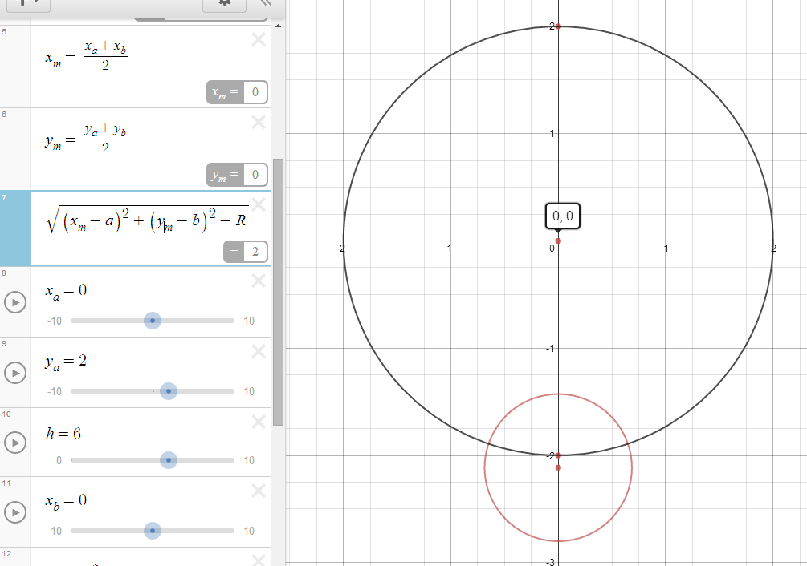
In the above image I have changed the value for λ to be equal to 6. In doing so the as I have mentioned earlier, where the two circle intersect is where the tangent to the circle exists. Due to this being the case, if we find out the radius of the circle, we know the length of the tangent. Using Desmos as shown above, it still gives us the length of the tangent to be equal to 2.

This therefore means that the tangent from the midpoint AB to the circle will always lie on the circle that is centred around the midpoint AB, and thus the length of the tangent is equal to the radius of the circle centred on the midpoint.

The only thing that changes as λ increases from 1 but not including 1, is that the tangent when closest to 1, is closest to the x-axis. As λ increases, the tangent will move further away from the x axis, however will retain along the circle centred on the midpoint of AB .

Through working it out this way I did not realise the shape that was traced by the tangent. As I already had a circle, however still ended up realising

Therefore the shape traced by the circle for values of λ < 1is the upper half of the circle (a semi circle), and for values of λ > 1 is the lower half of the circle (a semi circle), which thus when added together makes the circle that is centred on the midpoint of AB

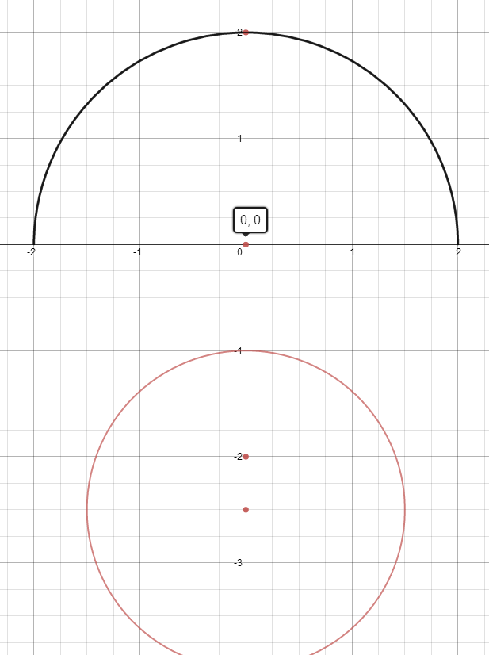
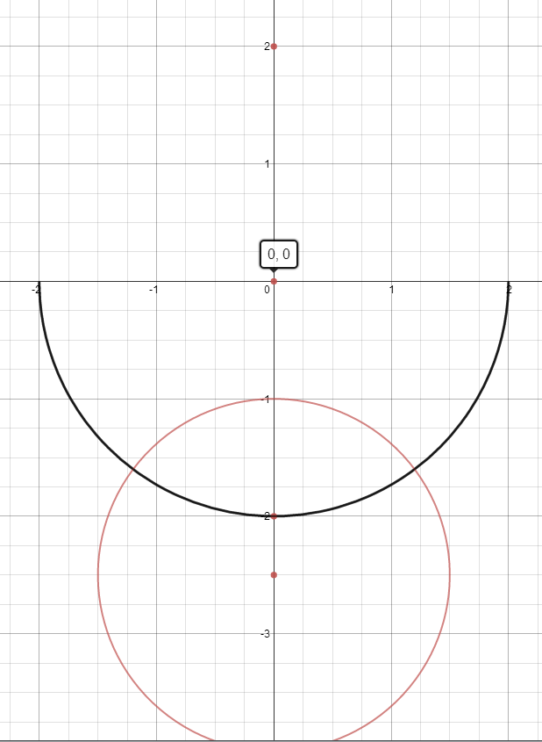

λ $>1$ λ $<1$

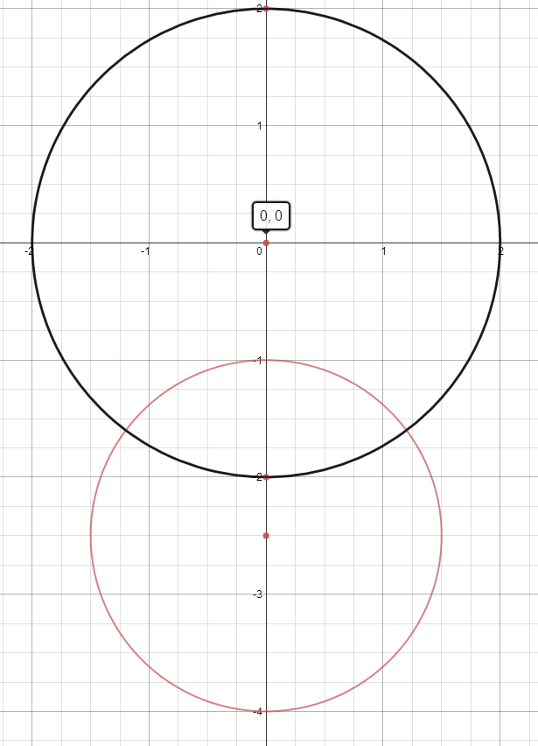

When both semi-circles are added together, they form the circle that is centred around the midpoint AB.

Further investigation that could lead on:

This investigation was all completed using the Cartesian plane and co-ordinates with real numbers. Instead of real numbers can we use complex numbers?

What would the equation on a complex plane look like?

Investigate:$\left|z-1+i\right|=z|z+3-i|$

What are the co-ordinates of the centre? What is the radius?

How is it similar to the Cartesian equivalent? How is it different?

