Thomas Hyde
Ibu Robinson
Water Report
The purpose of this report is to mesure the amounts of water used in a house hold of 4/3 people and to find ways to save water.

This investigation covers the amount of water used in an average size household.

I collected data from the kitchen and laundry through the orbit on the dishwasher and washer machine.

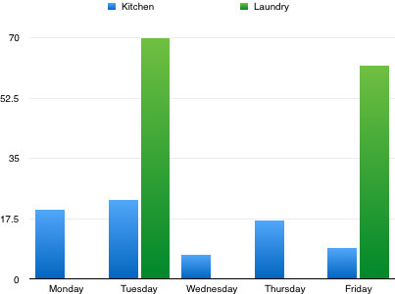
The data I collected in a Graph

I could save water by wearing less clouths and eating less food on dishes.

This task was very fun, enjoyable and interesting. I had a few minor setbacks as I accidentally my original report but luckily I'm such a good student I did it again. I'm sorry for the mistake.

