Finding Angles
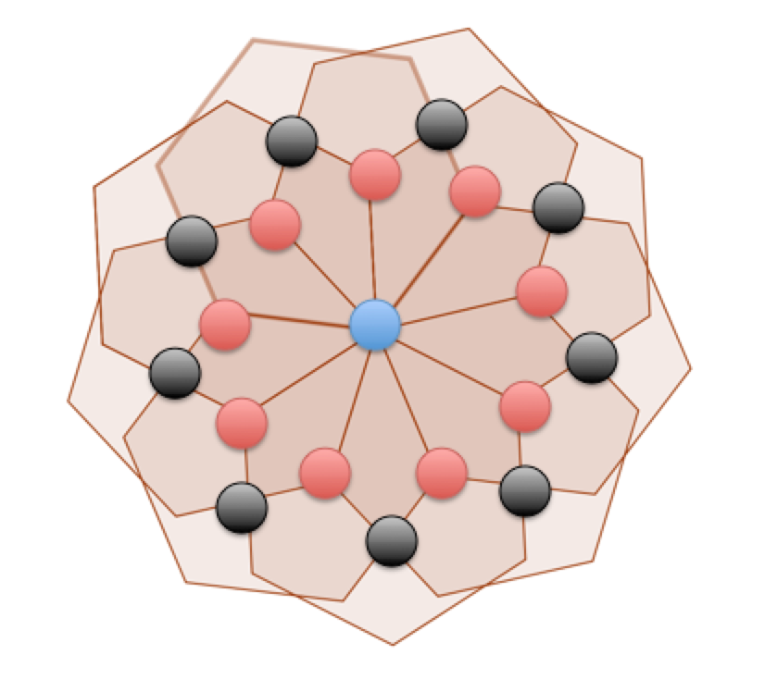

- The Angles around the blue dot are each 40 degrees, as the whole must equal 360, and all of the angles are equal due to the shape rotation of 40.

- The angles around the red dots are 120 degrees, as the whole must equal 360. These angles are all equal because the shape rotation is 40, and this causes these 3 angles to be equal.

- The angles around the black dots are 1 pair of 100 degrees, and 1 pair being 80 degrees. The pair, which each equal 80 and the angles that are up and down of the black dot which is directly below the blue dot. I worked these out be knowing that they are vertically opposite angles, so they must be the same. It had to be 80 due to the fact that a kite must equal 360 degrees, and we already know that the angles around the red dot equal 120, and the angles around the blue dot equal 40. So adding these up makes the other angle equal 80 degrees.

- The pair, which each equal 100 are the angles that are inside the irregular hexagons, or the ones, that are left and right of the dot when looking at the black dot directly below the centre blue dot. These are vertically opposite angles, so they have to be the same.

- The angles around the green dot equal 120 degrees and 240 degrees. The obtuse angle equals 120 because of the concave hexagon and how it must equal 360 degrees, and the reflex angle equals 240 because the whole must equal 360, and 360 minus 120 equals 240.

