The Square Under the Hypotenuse
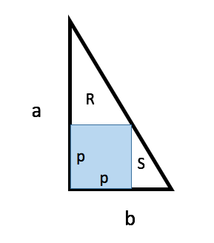
The first approach is using similar triangles R and S,

$$\frac{a-p}{p}=\frac{p}{b-p}$$

$$\left(a-p\right)\left(b-p\right)=p^{2}$$
$$ab-p\left(a+b\right)=0$$
$$p=\frac{ab}{a+b}$$

Another approach is by imagining the triangle on a coordinate axis.
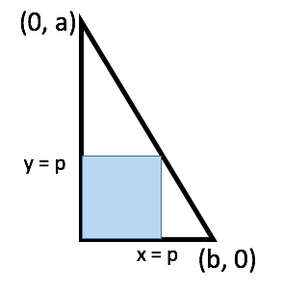
The equation of the line of the hypotenuse would be,
$$y=-\frac{a}{b}x+a$$
The square occurs when both y and x are equal to p
$$p=-\frac{a}{b}p+a$$
$$p\left(1+\frac{a}{b}\right)=a$$
$$p=\frac{ab}{a+b}$$

