The Solution and Answer to “Name That Graph Again”
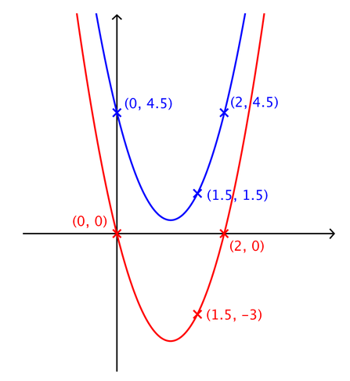
I would like to firstly begin by stating that my method for deriving and identifying the equation of the blue parabola revolved predominantly around graph transformations and difference of two squares.

I’m going to define the blue parabola as y=f(x)

I discovered that the red parabola, provided in the “hint” box, is simply a graph transformation from the blue parabola in the form y=f(x)+c where c is -4.5. In other words the graph is transformed in the y axis direction by -4.5 (the x values stay the same but the y values change)

I also figured out that the minimum point of the red parabola must have an x value of 1. I did this as I realised that the vertical line perpendicular to this point provides symmetry. I looked at the roots of the red parabola which are (0,0) and (2,0), and then worked out the x value by finding the midpoint of the x value- (0+2)/2= 1

Proceeding this, I then translated the red parabola left on the x axis by a value of 1; this parabola would have the equation y=f(x+1)-4.5. Consequently, the minimum point of the new parabola would have a minimum point where x=0 (y value is unknown), and the roots would be (-1,0) and (1,0).

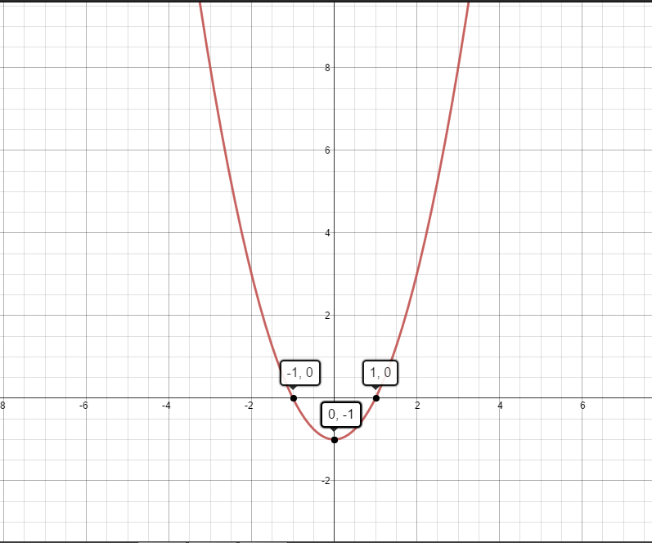
The general form of a quadratic is y=ax²+bx+c. I found that the value of bx must be zero as the new parabola is symmetrical about the y axis. This means it must have an equation y=ax²+c.
I simply then used difference of two squares and obtained the equation y=(x+1)(x-1)=x²-1
Let this equation be y=g(x)
The only problem was, although the roots were the same as the original graph of y=f(x+1)-4.5, other coordinates were not correct. This was because the scale factor (the value of a in y=ag(x)) was still 1. For example for y=g(x), when x=0.5, y=-0.75; it should have been -3. I then calculated the value of a: -3/-0.75 = 4
This now meant that 4g(x)=f(x+1)-4.5
Since g(x)= x²-1, 4g(x)= 4(x²-1)=4x²-4
Therefore, f(x+1)-4.5=4x²-4 I now need to undo the operations to get y=f(x)
This means f(x)= 4(x-1)²-4+4.5= 4x^2-8x+4.5

So the equation for the blue parabola is y= 4x²-8x+4.5

