Finding the solution for Gabriel’s Problem

In Gabriel’s Problem the numbers on each row and column need to multiply to make the pre-set values outside the grid. In addition, numbers can’t be repeated in two different boxes; one number needs to be written in only one box. Numbers that you can put in the grids go from 1 to 9.
This problem gave me more information than I needed because even if I didn’t know that the last row multiplied to be 378 and the last column to 288 I could be able to work out the number in the last box by excluding the others already used.
24
=2*3*4
=5*1*8
=6*7*9
2 | 3 | 4
5 | 1 | 8
6 | 7 | 9
40
=4*8*9
288
=3*1*7
21
=2*5*6
60
378
The multiplication of the 3 vertical results and the 3 horizontal results both multiply to 362880
In the problem below the order of the numbers is different and one of them has two solutions:

4 | 1 | 6
3 | 8 | 5
2 | 9 | 7

24
210
72
126
120
24
The multiplication of the 3 vertical results and the 3 horizontal results both multiply to 362880

4 | 1 | 7
2 | 8 | 9
5 | 6 | 3
28
The multiplication of the 3 vertical results and the 3 horizontal results both multiply to 362880
40
189
48
90
144

With these three examples I noticed that the multiplication of the 3 vertical results and the 3 horizontal results multiply to 362880, so the multiplication of the 6 results given is${362880}^{2}$= 1.21*${10}^{11}$. This means that the numbers need to be put in boxes so that the result given is a factor of 362880.

So how did Gabriel make these triangles?

Explanation | Image
- At the end of one row and at the end of one column he inserted a factor of 362880.  Factor 1=64  Factor 2=32 | 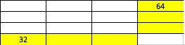
- Then he divided 362880 with the factor he chose at the end of the top row (so 362880/$F_{1}$). Then he did the same thing with the factor at the end of the first column (so 362880/$F_{2}$). | 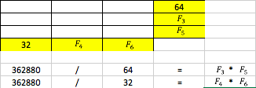
- Doing this operation, he finds the multiplication of the two other factors. (both for the top row and for the first column). | 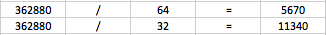
- He works out the two factors remaining that match with the result at the end of the column and with the result at the end of one row. To do this he uses trial and improvement. | 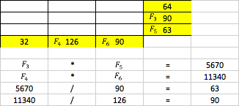
- Then he factorises the six factors in the yellow boxes and he finds the correct factors and inserts them with the correct combination in the table. If necessary he also needs to find the correct factor to put in each yellow box.

