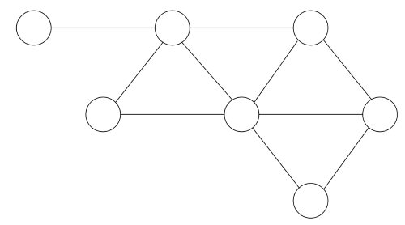

BELLA
FIONA
FRANK
ED
CHARLIE
BARNEY
ALAN
DANIEL

DAPHNE
EMILY
ANNA
GILL
CIARA

