Nrich Maths Solution
Connecting the Utilities
The first question is asking whether we can connect the two houses with the two utilities without the connections crossing. In this case, it is important where the utilities are positioned. In this case, if the utilities are positioned on top of each other, the problem is sorted out easily, as the diagram shows:
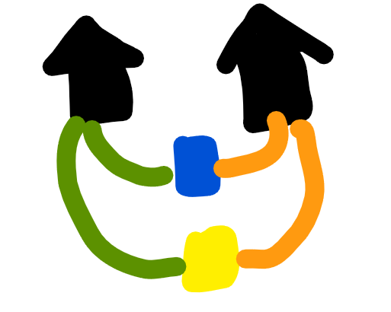
However, is it possible to have three houses and three utilities, but none of the connections may cross?
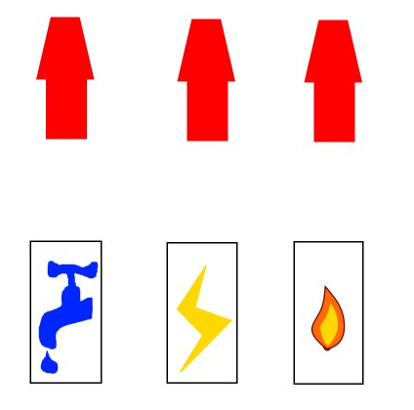
This however, is not. This can be shown using Euler’s Relation, developed by the Swiss mathematician Leonhard Euler. Euler showed that the number of vertices minus the number of edges and add the number of faces, give the constant 2.
i.e. V-E+F=2
In this case, the unknowns can be swapped for constants. The number of vertices, V, is 6 as there are 3 houses and 3 utilities. The number of edges, E, is 9 as there are 3 connections per house, i.e. 3*3=9. Now, the faces is a little tricky as the surface is 2-D. However, in this problem, the minimum number of faces has to be 4 as the face must comprise of the house to utility and utility to house at least.
So: V=6
E=9
And F=4
Substituting into the formula, we have:
V-E+F = 6-9+4=1
Since in 2-D form, the Euler number of an object has to be 2, this problem is not possible in 2-D.
But here is the way of solving this problem if the world was a torus. A torus can be represented graphically as a rectangle, so it can show how the problem can be resolved as we have the advantage of depth. The visualisation of the torus shape will need a degree of imagination, but the arrows on the edges of the rectangle are to be lined up in their pairs, so both pairs are facing the same direction. This forms the torus shape.
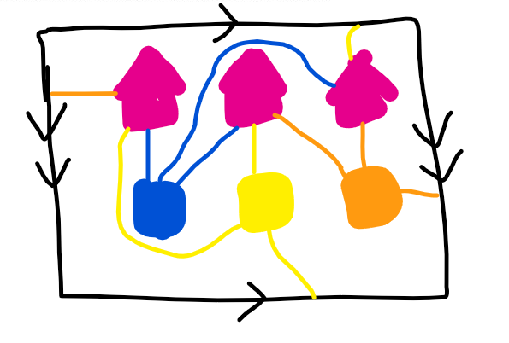

So, if the houses and utilities are drawn on the torus, the problem can be solved, as shown above.
To conclude, it is possible to connect up two utilities with two houses, depending on the position of both. However, it is not possible to connect up three houses with three utilities on a 2-D surface, as shown by Euler’s Relation, V-E+F=2.

