Can you Traverse it?

The way in which you can traverse a graph is related to number of edges a point is connected to.
In this graph, each point is connected to two edges. This means at each point you will arrive at it, and leave it.
This means wherever you start, you will end because you will repeatedly leave one point and arrive at another, every time you arrive at a point, you will only have one edge to travel on. You will end up at the start. With this graph, you can start anywhere and be able to complete it.
This graph is Eulerian.
The principle is the same for this graph as each point is connected to an even number of edges. With four edges on a point, you will arrive and leave each point twice. You can do this by splitting it into graphs with each point connected to two edges.

This graph contains points with an odd number of connecting edges. If a point is connected to an odd number of edges, either leaving a point or arriving at a point, will not occur. This means you need to start at one point which is connected to three edges, and you will finish at the other. If you start anywhere else, you will end there and be un-able to get to the edge which connects the points which are connected to an odd number of edges. This type of graph is semi-Eulerian.

However you cannot complete this graph because it has more than two points which are connected to an odd number of edges. If you start in the centre, you will end in the centre but will have missed out two edges and be unable to get to them.
If you start at any corner, you will finish at another corner but will have missed out the edges that connect the other two corners. This type of graph is non-Eulerian.
2
2
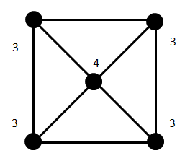
3
3
2
2
2
2
4
4
4
4
2
2

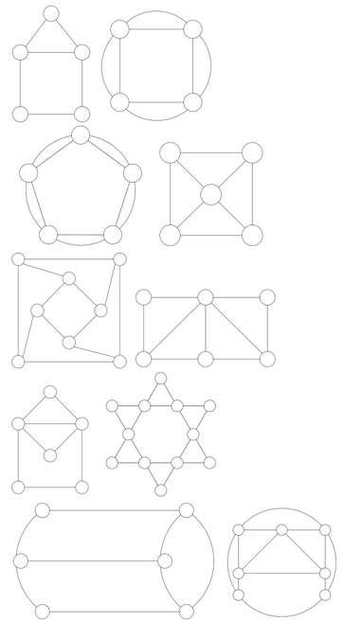
Non-Eulerian as more than two points are connected to 3 edges.
Non-Eulerian as more than two points are connected to 3 edges.
Eulerian as each point is connected to an even number of edges.
Eulerian as each point is connected to an even number of edges.
Non-Eulerian as more than two points are connected to an odd number of edges.
Non-Eulerian as more than two points are connected to 3 edges.
Non-Eulerian as more than two points are connected to 3 edges.
Eulerian as each point is connected to 4 edges.
Eulerian as each point is connected to 4 edges.
Semi-Eulerian as two points are connected to 3 edges.

