Isometric Area’s

So, since one equilateral triangle is equal to sides length of one.
SO, for the first one I drew equilateral triangles and then counted how many triangles there are.
Therefore, for A is 16T

Using the method, I found out the others:
Shape | Area
A | 16T
B | 24T
C | 24T
D | 4T
E | 16T
F | 18T
G | 8T
H | 12T

After that I found out the edges for each parallelogram. Since I knew that the sided of one equilateral triangle is equal to 1.
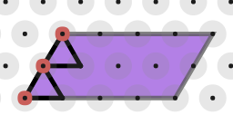
So, each triangle’s base is = to 1, and if you count there should be 2 bases for side (a) If we do the same but for the top side (b) the length should be 4.
b
a

I use the same method to find the other side:
Shape | Side a | Side B
A | 2 | 4
B | 3 | 4
C | 2 | 6
D | 1 | 2
E | 4 | 2
F | 3 | 3
G | 2 | 2
H | 2 | 3

With these two tables I noticed that a parallelogram is a tilted rectangle. Also, I noticed that if we find out the area like a square (b x h) but we must times it by two. I think this is because the shape is tilted therefore it will take more triangles.
I have generalised a formula to find out a parallelogram on isometric paper:
A = 2(bxh)

For trapeziums

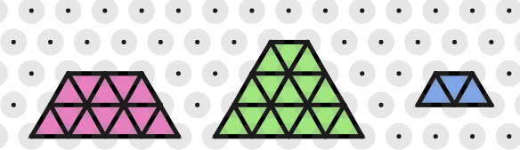
For trapeziums, I used the same method. I drew triangles and counted to find the area. I also used the bases of the triangles to find the length of the sides.
d
c
a
b

Shape | Area | Side a | Side b | Side c | Side d
Pink | 12 | 2 | 2 | 2 | 4
Green | 15 | 3 | 1 | 3 | 4
Blue | 3 | 1 | 1 | 1 | 2

I have noticed that side a and side c has the same length. I have also noticed that if you add side b and d together and then times it by side c then it will equal to the area.
Example Shape pink:
2(2+4) = 12
Therefore, A=12

I generalised a formula for finding a trapezium on isometric paper:
A= c(b+d)
c= right or left side
b= top side
d= bottom side

