Isometric Areas

Stage: 3

Here is an equilateral triangle with sides of length 1.



Let's define a unit of area, T, such that the triangle has area 1T.

Here are some parallelograms whose side lengths are whole numbers.

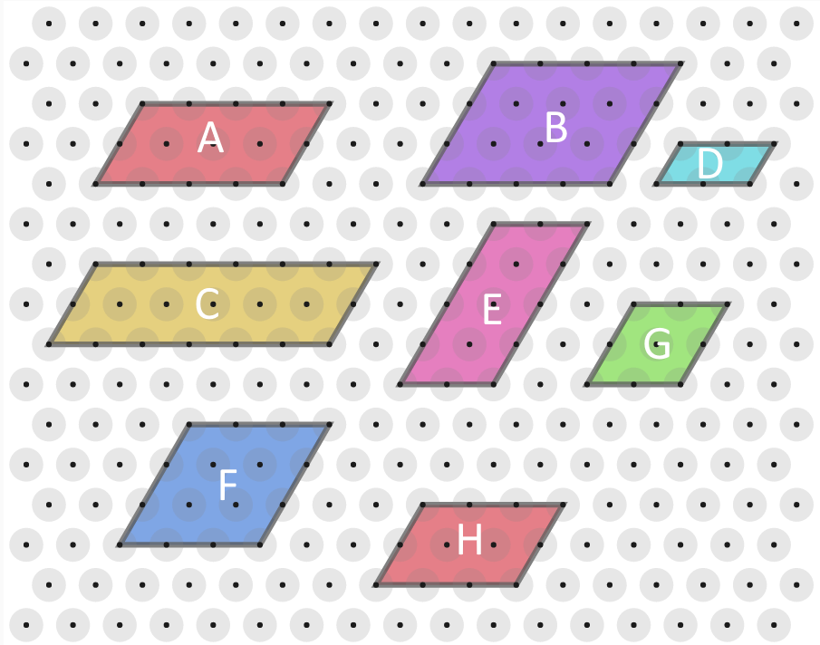

Can you find the area, in terms of T, of each parallelogram?
Compare the results with the lengths of their edges.
- Area = 16T Side Length = 4 and 2
- Area = 24T Side Length = 4 and 3
- Area = 24T Side Length = 6 and 2
- Area = 4T Side Length = 2 and 1
- Area = 16T Side Length = 2 and 4
- Area = 18 Side Length = 3 and 3
- Area = 8 Side Length = 2 and 2

What do you notice?
Can you explain what you've noticed?
In terms of T, Each Trapeziums Area is formed in the formula of 2LW where LW = the length * diagonal width. This is because there are 2 triangles in one unit for this formula.

Can you find a similar result for trapeziums in which all four lengths are whole numbers?

Trapeziums with their lengths as whole numbers can have areas in terms of T.
It is different from the Triangles task because there were 2 triangles in each unit. In this one the formula is (L*2) -1 to make the amount of triangles on the base. Every Time the trapeziums height is increased by one, the width is decreased by 2.

So the formula is L= (((L*2)-1) * H) - 2H

Where you find the base length and * it by the Slant Height and minus it by the triangles that are deducted off every time the trapezium increases in height by 1.

