- To find the area of the parallelogram you would have to do the base x height x 2.
This is because on the isometric paper the triangle T is half a normal 1x1 square in which you usually measure shapes in. Therefore you would have to multiply by two.
This is the base and height -----> 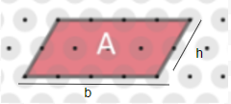
(Notice that the height is the
Diagonal not the vertical)

- To find the area of the trapezium you would have to find the length of base number 1 + the length of base number two x height; ((Base A + Base B) x H) (height)=The area
This is because usually the formula would be ((Base A + Base B) x H) Divided by 2. However because the isometric triangle is half the normal square then you would times two and it would cancel the divided two out.

