Paired Parabolas

What's the same and what's different about the following pairs of equations?
1) y=x²-4 and y+x²-4=0 (rearrange to make y subject: y=4-x²)
2) y=4-9x² and y+4=9x² (rearrange to make y subject: y=9x²-4)
3) 2y=4x²-6 (divide whole equation by 2: y=2x²-3) and -(y-3)=2x² ( rearrange to make y subject: y=3-2x²)

It can be seen that for all the parabola pairs, the equations are reflections of each other with the line of reflection being the x axis. So if we defined the first parabola of any of the pairs as f(x), the second parabola would be –f(x). The obvious features of the equations are that they are all quadratic equations, and they all also revolve around the difference of two squares- in other words for y= ax²+bx+c, bx=0. So for example, number 1, y=x²-4, can be written as y=(x+2)(x-2) and y=4-x² can be written as y=-(x+2)(x-2). Since the coefficient of x² in number 2 and 3 is greater than 1, this means that the graph is going to be more stretched parallel to the y axis, than the quadratics in number 1. Also the roots of the quadratics in number 1 are integer solutions whereas in numbers 2 and 3 they are non-integer solutions.

If you were given the following picture, could you suggest the equation of its pair?
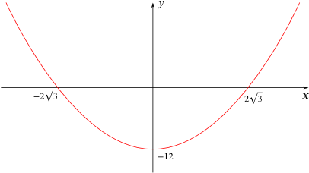
First I will find the equation of this red parabola. It can be seen that this is also an example of difference of two squares so the equation would be y= x²-12 coming from y=(x+2root3)(x-2root3). So I would guess that the “pair” of this quadratic would have an equation which would show the reflection of this parabola through the x axis: y=-(x²-12) so y=12-x² is the equation of the pair.

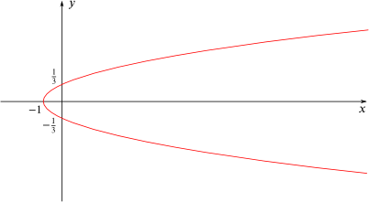
How about if you were given this picture instead?
Could you give the equation of its pair?

First of all, this isn’t the conventional quadratic with y=…. But it is x=… (sideways parabola?). The roots of this graph on the y axis are 1/3 and-1/3 so again it is related to the difference of two squares: x=(y+1/3)(y-1/3)- however this isn’t quite the correct equation of this parabola as the graph crosses the x axis when x=-1 and not when x= -1/9. This means there is a scale factor involved and to find this we do (-1)/(-1/9)=9. So the actual equation is x=9(y+1/3)(y-1/3)= 9y²-1. This means the equation of the pair of this graph is x=1-9y²

