Nrich Soln for Domino Magic Rectangle (3)

This task was given as homework in Ganit Kreeda, Vicharvatika, India and sharing the solutions submitted by Adithya.

First, I managed to get 24 in all columns. The rule which I used is- I noticed that only if we get the sum of the dots on the dominoes as 2 even and 2 odd or all odd or all even, we can get the sum as 24 without falling short of dominoes. An example of how I added up the rows-
The last 2 rows had 34 and 35 as their totals consecutively. In the last column I noticed 2 tiles. 4,1 and 3,3. I replaced them and got the totals as 42. For even better explanations, please view my work attached below.

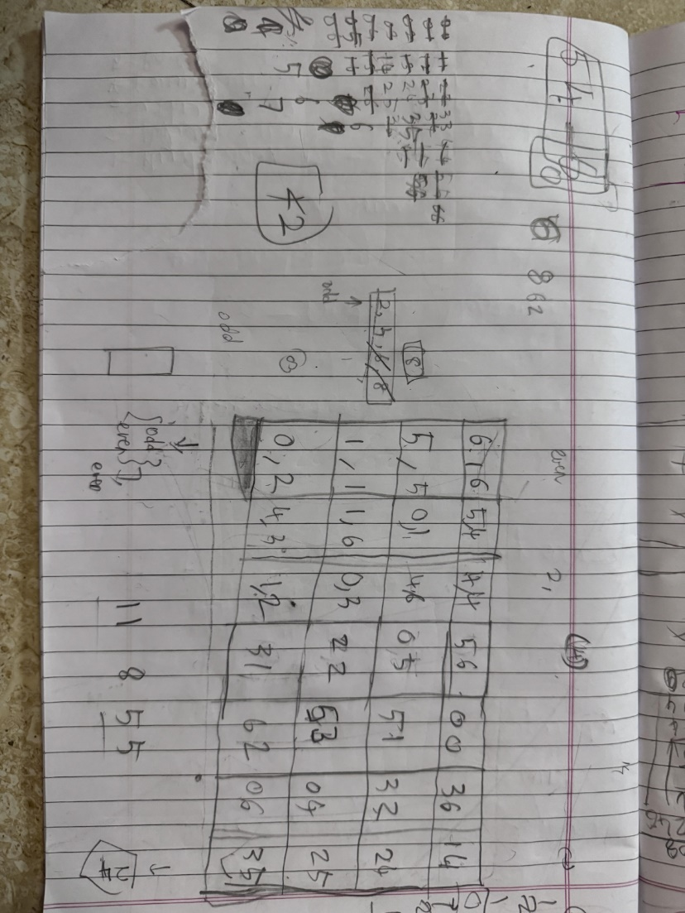
My working before adding up the rows
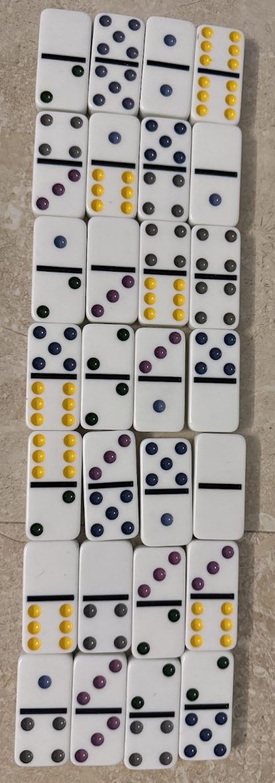
My work after adding up the rows

