Proving Half-angle Formulae
RTP: cos²(θ/2) ≡ 1/2(1+cosθ)

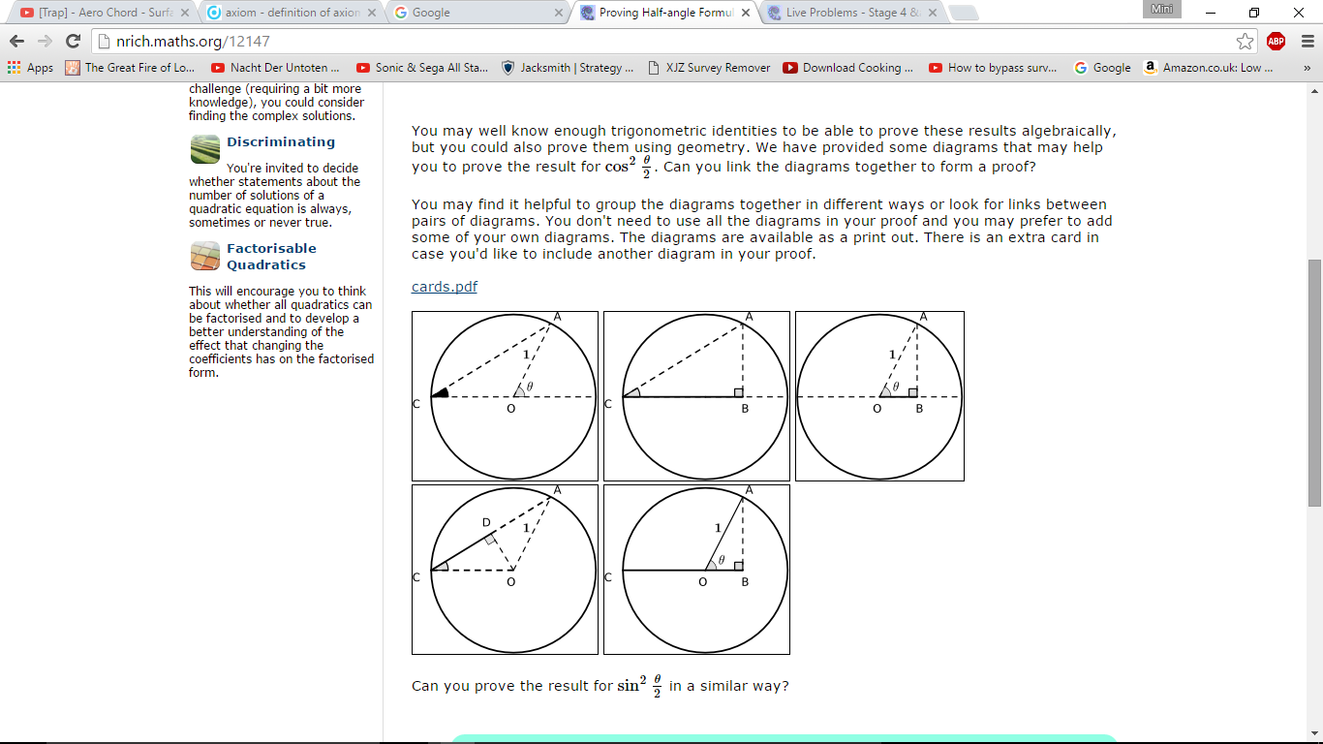
Method 1:
(2 Cos θ + 2)^{1/2}
Sin θ
Cos θ + 1
Sin θ
θ/2
Cos θ
θ/2
θ/2
1
1) Triangle COA is an isosceles (CO and OA are both radii of the circle and hence have a length of 1)
2) ∠OCA and ∠CAO are equal (base angles on an isosceles are equal)
3) ∠OCA and ∠CAO are θ/2 (The measure of θ which is an exterior angle of triangle COA is equal to the sum of the measures of the two non-adjacent interior angles, ∠OCA and ∠CAO)
4) Cos θ = OB (Cos θ = adjacent/hypotenuse of triangle OBA where adjacent=OB and hypotenuse=OA=1, OB/1 = OB)
5) Sin θ = AB (Sin θ = opposite/hypotenuse of triangle OBA where opposite is AB and hypotenuse is OA which is 1, AB/1= AB)
6) Cos θ/2 = (OB+1)/CA= (Cos θ + 1)/CA (For triangle ABC, CB which is Cos θ + 1, is adjacent to angle θ/2 and CA is the hypotenuse)
7) CA= (2 Cos θ + 2)^{1/2} ( CA²= (Cos θ + 1)² + Sin² θ = (Cos θ + 1)² + (1 – Cos² θ)= 2 Cos θ + 2 )
Sin² θ + Cos² θ = 1 (known identity)
Pythagoras’ Theorem

8) ∴ Cos θ/2 = (Cos θ + 1)/ (2 Cos θ + 2)^{1/2} (substitute CA for (2 Cos θ + 2)^{1/2} )
9) ∴ Cos² θ/2 = [(Cos θ + 1)/ (2 Cos θ + 2)^{1/2}]² = (Cos θ + 1)²/ (2 Cos θ + 2)
= (Cos θ + 1)²/ (2( Cos θ + 1))= (Cos θ + 1)/2

∴ cos²(θ/2) ≡ 1/2(1+cosθ) QED

Method 2 (Continuation from Method 1):
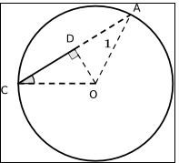
θ/2
Note: In triangle AOC, lines CD and DA are equal (circle theorem: OD passes through the centre of the circle and is the perpendicular bisector of the chord CA, therefore since it bisects CA, CD=DA)
1
θ/2

1) Cos θ/2 = CD/1 =CD, since CD=DA, DA = Cos θ/2
2) CA= CD+DA = 2 Cos θ/2
3)From method 1, we know that CB= Cos θ + 1 and AB= Sin θ
4) From Pythagoras’ theorem, CB²+ AB²= CA²
∴ through substitution (Cos θ + 1)²+ Sin² θ = 4 Cos² θ/2
Sin² θ= 1 - Cos² θ and so ∴ (Cos θ + 1)² + (1- Cos² θ)= 4 Cos² θ/2
∴ Cos² θ + 2 Cos θ + 1 + 1 - Cos² θ = 4 Cos² θ/2
2 Cos θ + 2 = 4 Cos² θ/2
Cos² θ/2 = (2 Cos θ + 2)/4
= (Cos θ + 1)/2
∴ cos²(θ/2) ≡ 1/2(1+cosθ) QED

RTP sin² (θ/2) ≡ 1/2(1−cosθ)
Method 1:
θ/2
Cos θ
1
θ/2
Cos θ + 1
Sin θ
(2 Cos θ + 2)^{1/2}
Sin θ
θ/2
1) Triangle COA is an isosceles (CO and OA are both radii of the circle and hence have a length of 1)
2) ∠OCA and ∠CAO are equal (base angles on an isosceles are equal)
3) ∠OCA and ∠CAO are θ/2 (The measure of θ which is an exterior angle of triangle COA is equal to the sum of the measures of the two non-adjacent interior angles, ∠OCA and ∠CAO)
4) Cos θ = OB (Cos θ = adjacent/hypotenuse of triangle OBA where adjacent=OB and hypotenuse=OA=1, OB/1 = OB)
5) Sin θ = AB (Sin θ = opposite/hypotenuse of triangle OBA where opposite is AB and hypotenuse is OA which is 1, AB/1= AB)
6) ) Sin θ/2 = AB/CA= Sin θ /CA (For triangle ABC, AB which is Sin θ, is opposite to angle θ/2 and CA is the hypotenuse)
7) CA= (2 Cos θ + 2)^{1/2} ( CA²= (Cos θ + 1)² + Sin² θ = (Cos θ + 1)² + (1 – Cos² θ)= 2 Cos θ + 2 )
8) ∴ Sin θ/2 = Sin θ / (2 Cos θ + 2)^{1/2} (substitute CA for (2 Cos θ + 2)^{1/2} )
9) ∴ Sin² θ/2 = [Sin θ / (2 Cos θ + 2)^{1/2}]² = Sin² θ / (2 Cos θ + 2)
= (1 – Cos² θ)/ (2( Cos θ + 1))= -( Cos θ+1)( Cos θ-1)/ (2( Cos θ + 1)) = -( Cos θ-1)/ 2 = ½ (1 - Cos θ)
∴ sin² (θ/2) ≡ 1/2(1−cosθ) QED
Method 2 (Continuation from Method 1):
Note: In triangle AOC, lines CD and DA are equal (circle theorem: OD passes through the centre of the circle and is the perpendicular bisector of the chord CA, therefore since it bisects CA, CD=DA)
1
θ/2
θ/2

1) Cos θ/2 = CD/1 =CD, since CD=DA, DA = Cos θ/2
2) Sin θ/2 = DO/1 = DO
3) DO² = 1 – CD² (Using Pythagoras’ Theorem)
4) ∴ Sin² θ/2 = 1 – Cos² θ/2 (through substitution)
5) We have already proved the identity cos²(θ/2) ≡ 1/2(1+cosθ)
6) ∴ Sin² θ/2 = 1 - 1/2(1+cosθ) = (2 – 1 – cosθ )/ 2 = (1- cosθ)/2
∴ sin² (θ/2) ≡ 1/2(1−cosθ) QED

