Solution for Painting Possibilities

Myself, Shubhangee, had worked in Ganit Kreeda, Vicharvatika with 15 kids, Viha, Abhiram, Eshann, Anirved, Arya, Rivaan, Miraya, Asma, Aprameya, Vibha, Rudraraj, Nithyashree, Adhrit, Kathir, Arnav of 4th and 5th grade worked on Painting Possibilities.

CHALLENGE 1
- How many units of paint have been used to turn the multi-coloured box (A)
into the painted box (B)?

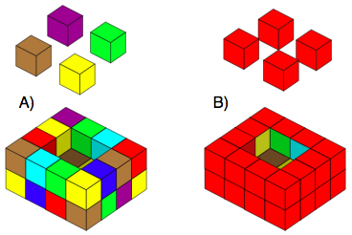
Solution:
We discussed this task in the session and tried to find out the solution collaboratively. Three different kids have used three different approaches to count the total number of faces to be coloured (which is equal to required units of paints).

Anirved simply counted the number of faces and he found it 32 on sides and 12 on the top; that way making it 44.
Rivaan used different technique. He first counted cubes and then their faces from bottom row, top row separately as:
From bottom row,
4 Corner cubes have 2 faces coloured. So, 4 x 2 = 8 faces.
In between there are 2 cubes, with 1 face coloured, on all the 4 sides i.e. total 4 x 2 = 8 faces.
From Top Row,
4 Corner cubes have 3 faces coloured. So, 4 x 3 = 12 faces.
In between there are 2 cubes, with 2 face coloured, on all the 4 sides i.e. total 4 x 2 x 2 = 16 faces.
Total faces = 8 + 8 + 12 + 16 = 44.
Kathir said there are 4 sides and each side have 8 faces coloured.
So, 4 x 8 = 32. And he counted the top faces separately as
4+ 4 +2 + 2 = 12. Total is 44.
- How many units of paint have been used to cover the four cubes
that fit in the box?
Solution: As each cube was painted all over and each cube has 6 faces, kids calculated the total units of paint required as
# of cubes x # of faces = 4 x 6 = 24.

3. How many units of paint have been used for the outside of the box?
How many units of paint have been used to cover the twelve cubes which fit inside it?
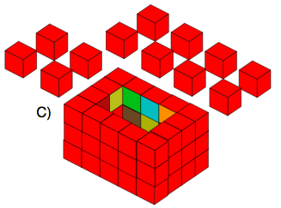
They worked on this using one of the above methods to get answers as 68 units and 72 units.
Kids collaboratively experimented with different combinations of boxes and generalized the method for:
no. of cubes that will go inside the box and no. of outside faces to be coloured as:

To calculate no. of cubes, we removed 2 from length and width as each of the 2 walls is 1 cube thick. And we removed 1 from height as it has a base of 1 cube thickness.
Finally,
no. of cubes that will go inside the box = (l - 2) (w -2) (h - 1)
where l = length, w= width and h = height

and total no. of faces to be coloured of individual cubes = (l - 2) (w -2) (h - 1) x 6

To calculate no. of outside faces, we used 2 different approaches as:

Being a cuboid, 2 opposite sides are identical. So, no. of faces for one side which is (l x h) is doubled. Similarly, other side has (w x h) faces and it is also multiplied by 2. Then we added faces on the top which are 2l and 2(w-2) [as 2 corner common faces are already counted in length].

For second formula, we used different approach for counting faces on the top. We just doubled (l+w) and removed 4 as 4 corner faces are counted 2 times.

no. of outside faces to be coloured = 2(lxh) + 2(wxh) + 2l + 2(w-2) or
= 2(l x h) + 2(w x h) + 2(l + w) – 4

Asma and Vibha have very well explained this here in the pdf

https://drive.google.com/drive/folders/1MYYJ4aRvUli11tXdu07zkK-S3VesTIAl?usp=drive_link

CHALLENGE 2

Find the size of an open box that needs the same amount of paint to cover the cubes that fill it as its outside.
Rivaan beautifully explained his work of exploration using algebra, formula and technology.
He tried to equate two formulae as
Paint required for cubes = Paint required for outside of Box
6(l-2)(w-2)(h-1) = 2(lxh)+2(wxh)+2l+2(w-2)
He simplified it further using algebra to get
6lhw-6lw+24h = 14lh+14wh-10l-10w+20
Then he used spreadsheet and tried for different box dimensions. All the kids tried it with him, but we couldn’t find any combination. We even tried to use Geogebra for this activity.

CHALLENGE 3

In diagram B, the number of units of paint needed to cover the box is 20 more than the number needed to cover the four cubes that fill the box.

2. Can you find some more open boxes which use 20 more units of paint to cover their outsides than to cover the cubes that fill them?
They used trial and elimination technique.
Box Dimn | # Cubes | Paint for Cubes | Paint for Box
4x4x2 | 4 | 24 | 44
5x4x3 | 12 | 72 | 68
5x4x2 | 6 | 36 | 50
5x4x4 | 18 | 108 | 86

Anirved found one combination for 2nd question from challenge 3.
