The sum of three consecutive numbers is divisible by 3.
always
When it comes to this challenge, we chose to work on it as the whole class. First, we brainstormed our ideas and we decided to investigate a variety of consecutive numbers. Then, we worked in pairs on a different set of numbers and finally we compared our findings.
1.
Martyna and Phillip investigated the three consecutive numbers where the first number was divisible by 3:
Phillip
I checked a couple of sets of consecutive numbers, here is one of them:
3+4+5=12
12:3 = 4
I have found out that all of the sums were multiples of 3.
When I compared my findings with my partner and we discovered that the statement was always true.
Martyna
I chose my numbers randomly but the first number had to be divisible by 3. I found out that every time I started with number that was divisible by 3, added two consecutive numbers to it and divided it by 3 the statement was always correct.
2.
Olivier and Anika investigated the three consecutive numbers where the middle number was divisible by 3:
Olivier
I checked many sets and discovered that we could calculate next numbers without checking every set of 3 consecutive numbers.

11+12+13 = 36 36:3=12
14+15+16 = 45 45:3=15
17+18+19 = 54 54:3=18

I noticed that the middle numbers kept going up by 3 and the answer kept going up by 3 too.

Anika
When you choose a number which is divisible by 3 and use it as your middle number in a set of three consecutive numbers, the total of your set is always divisible by 3.

My examples: 8+9+10=27 27:3=9
11+12+13=36 36:3=12
14+15+16=45 45:3=15

3.
Phillip and Hania investigated the three consecutive numbers where the last number was divisible by 3:
Phillip
31+32+33=96 96:3=32
97+98+99 = 294 294:3=98
Hania
I noticed that the sum of each set of three consecutive numbers was always divisible by 3. I came to the conclusion that it did not matter where the number divisible by 3 was in the set. In every example (if it doesn’t start from 0) there is at least one number which is divisible by 3. The sum of other two also gives the number which is divisible by 3. This works in any case even if the number divisible by 3 is first, middle or last in the set.
4.
Phillip investigated the three consecutive numbers 0 was the first number in the set:
Phillip
0+1+2=3 3:3=1
As a whole class we checked this set as we wanted to see if it worked when 0, 1 and 2 were the ones numbers:
10+11+12 = 33 33:3=11
2340+2341+2342 = 7023 7023:3=2341
The statement was also true. What is more, the answer to the division was the same as the middle number in our sets.
5.
Adam and Sebastian investigated the three consecutive numbers which were less than 10:
Adam
All numbers that are 1-digit numbers are 1,2,3,4,5,6,7,8,9.
I wrote the 1-digit numbers down and wrote all the possible patterns that include all the 1-digit numbers.
0,1,2
1,2,3
2,3,4
3,4,5
4,5,6
5,6,7
6,7,8
7,8,9
Then after I wrote them down, I proceeded to add the whole pattern together to get a whole number.
0+1+2= 3 3:3 =1
1+2+3= 6 6:3=2
2+3+4= 9 9:3=3
3+4+5= 12 12:3=4
4+5+6= 15 15:3=5
5+6+7= 18 18:3=6
6+7+8= 21 21:3=7
7+8+9= 24 24:3=8
All sums of three consecutive numbers were divisible by 3.

Sebastian
I chose numbers from 1 to 9. So I started with adding all numbers together and then I divided all sums by 3 and it showed that all of them were divisible by 3.

What did i did:
0,1,2 0+1+2= 3 3/3=1
1,2,3 1+2+3= 6 6/3=2
2,3,4 2+3+4= 9 9/3=3
3,4,5 3+4+5= 12 12/3=4
4,5,6 4+5+6= 15 15/3=5
5,6,7 5+6+7= 18 18/3=6
6,7,8 6+7+8= 21 21/3=7
7,8,9 7+8+9= 24 24/3=8

Then I noticed that every next number (the red one) was 3 more.
Also, I found that all the answers of division (the green one) were 1 more.

6.
Kinga investigated the three consecutive 2-digit numbers:
Kinga
My findings were pretty interesting. Firstly, every time you choose any three 2 digit-numbers they are always divisible by 3 without any remainders.

For example:
61 + 62 + 63 = 186 : 3 = 62
12 + 13 + 14 = 39 : 3 = 13
43 + 44 + 45 = 132 : 3 = 44

I noticed a pattern in my answers. The answer was always the middle 2 digit-number (62, 13, 44). To make the division easier, you can divide the total of the three 2 digit-numbers by 3, then add all the units up and check if the answer is divisible by 3 - see my first example – the total is 186 so you can add 1 + 8 + 6 = 15 15:3 = 5. That’s an easier way to check the answer.

7.
Hania and Ala investigated the three consecutive numbers 3-digit numbers:
Ala
I think that this always works, it doesn’t matter which three consecutive numbers I choose. In a set of random three consecutive numbers there’s always one of number that is divisible by 3, and if you take the other two numbers and add them, the score is also divisible by three. I drew a triangle to show my findings:
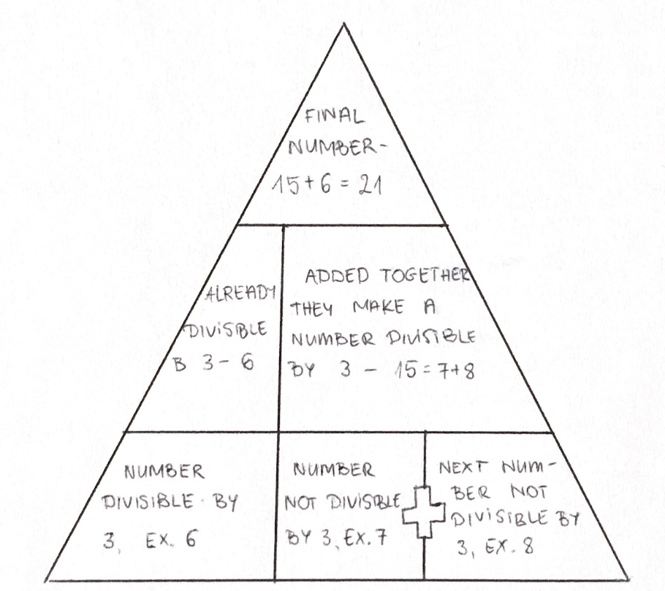
Hania
I checked whether the sum of three consecutive 3-digit numbers was divisible by 3. The fact that intrigued me was that in each example at least one number was divisible by 3 and the sum of other two gave the number which was divisible by 3. When we add three 3-digit numbers the sum is always divisible by three so the statement is always true.
8.
Grzegorz and Francesca investigated the three consecutive negative numbers:
Francesca
First, I had to choose a random negative number. I chose to check these numbers :
-20,(-21),(-22)
After that I added them and then I divided the total by 3 :
-20+(-21)+(-22)= (-63):3=(-21)
As I solved the calculation I noticed that the answer would always be negative and the answer was the middle number that I added to find my total. I was shocked by the answer because I never thought that that would be the answer.

Grzegorz
Looking at these 3 consecutive numbers I noticed, that since they are just opposites, means the number will definitely be negative, but whole. However, if we divide the number by -3, our answer will be positive, since subtracting a negative from a negative means adding the subtrahend to the minuend.

