Live nRich Solution for Always Sometimes Never
(https://nrich.maths.org/12671)

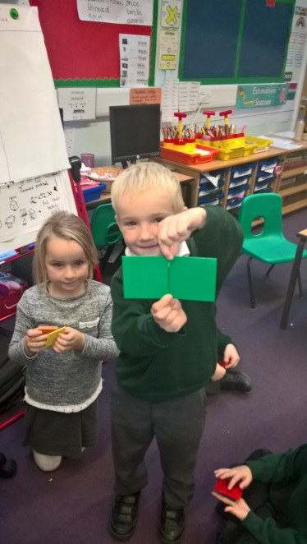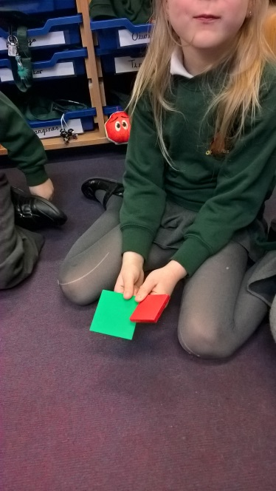
nRich asks: If you put 2 squares together, you get a rectangle.
Dangiras said, “My 2 squares didn’t make a rectangle at all. They did make a shape with 8 sides though - this is an octagon.”
Jore and Emilis said, “Our 2 squares made a rectangle, but only if we put 2 sides right next to each other….”
Guste said, “Mine didn’t work either, but the squares were different sizes, so it would never make a rectangle.”
We found some examples that worked. And we found some that didn’t work. (Our teacher said that these were counter examples…) We all agreed that it was sometimes true.
Leon then noticed something else. He said that he could use 3 squares to make an even longer rectangle. He said it will work for any number… and the rectangle would go on forever.

