Live nRich Solution for Always Sometimes Never
(https://nrich.maths.org/12671)
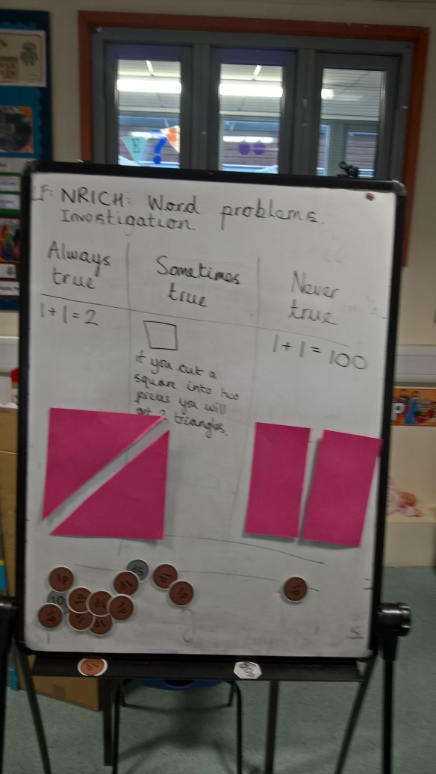
nRich asks: If you cut a square in half, it makes a triangle.
We cut our square from corner to corner - it made 2 triangles.
But when we cut from side to side, it made 2 rectangles.
We all agreed that it was sometimes true.

