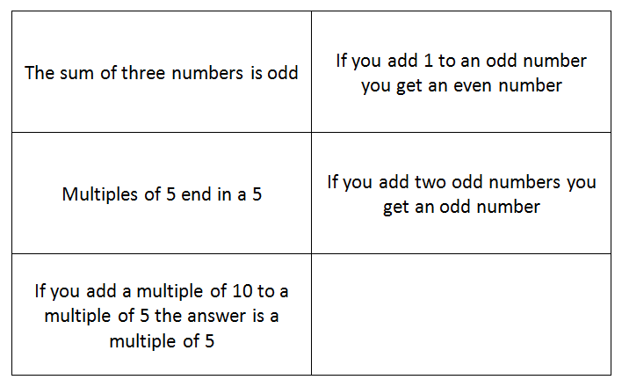

Q.1 The sum of three numbers is odd is sometimes true
6+6+6 = 18, 5+5+5+ = 15
Q.2 if you add 1 to an odd number you always get an even number
1+1=2 even number, 15+1=16 even number
Q. 3 multiples of 5 end in 5 is sometimes true.
5,10,15,20,25,30,35 they end in a 5 or a 0
Q.4 if you add 2 odd numbers you get an odd number is never true
99+99=198
Q.5 If you add a multiple of 10 to a multiple of 5 the answer is a multiple of 5 is always true.
60+5=65 and 13 5s go into 65, 90+5=95 and 19 5s go into 95

