Always True Sometimes true Never true

Squares have two A hexagon has six equal When you cut off a piece from
diagonals that meet at length sides if it's regular. A 2d shape, you reduce the area
right angles because all Triangles have a line of but not the perimeter.
the vertices are right symmetry if they're
angles always. regular.

Cutting a corner off a
square makes a pentagon A cuboid has two square
because it would make an faces but they could also
extra side which makes a be rectangle faces.
pentagon.
The base of a pyramid is
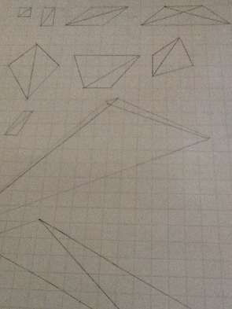
Triangles tessellate square if it's a square
Because they fit perfectly based pyramid.
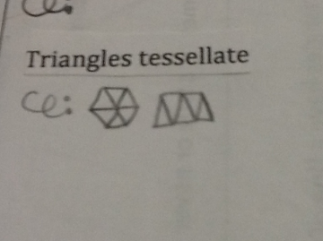
Into each other.
Quadrilaterals can be cut
into two equal triangles
if they're regular.

The number of lines of symmetry
In a regular shape is equal to
The number of sides in some
Shapes.

