Always, Sometimes, Never Shape

- ‘A hexagon has six equal length sides.’

Sometimes. This question can be proved right but it can also be proved wrong.
Example: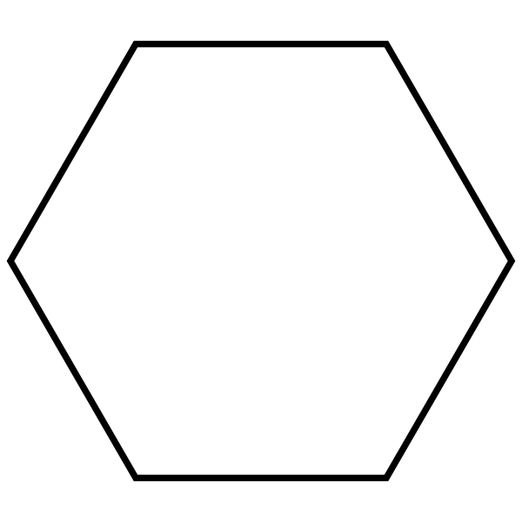
Counterexample: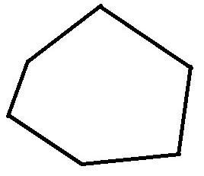

Explanation: There are examples of regular hexagons that have equal length sides but there are also examples of irregular hexagons that have different length sides.

- ‘Squares have two diagonals that meet at right angles.’

Always. This question can only be proved right.
Example: 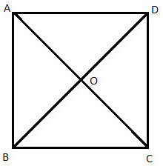

Explanation: A square always has 4 equal length sides so the diagonals will always meet at right angles.

- ‘The base of a pyramid is square.’

Sometimes. This question can be proved right and it can be proved wrong.

Example: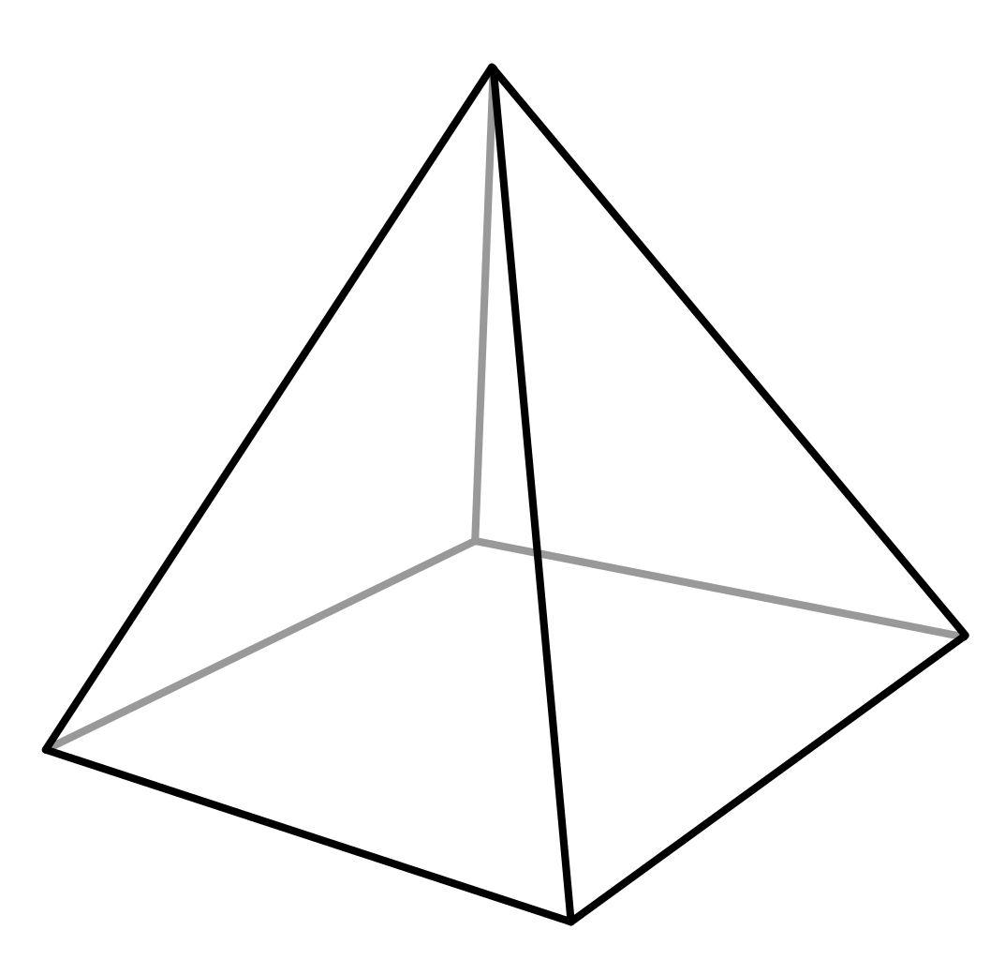

Counterexample: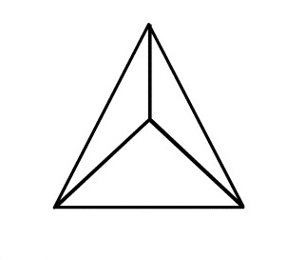

Explanation: It is possible to have a square based pyramid but it is also possible to have a different 2d polygon - regular or irregular - on the bottom of a pyramid.

- ‘Triangles have a line of symmetry.’

Sometimes. This question can be proved right and wrong.

Example: 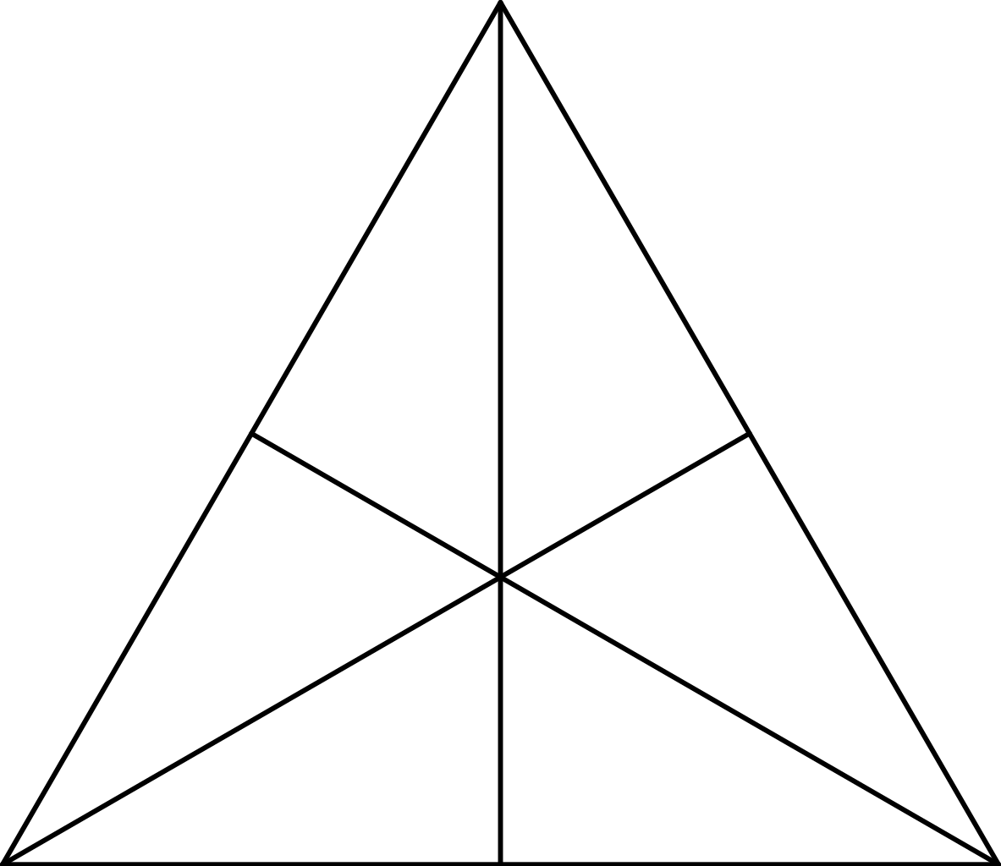

Counterexample: 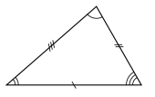

Explanation: Both the isosceles and the equilateral triangles have lines of symmetry but scalene triangles do not. This is because a scalene triangle doesn’t have any sides which are the same length so there cannot be a line of symmetry.

- ‘Cutting a corner off a square makes a pentagon.’

Sometimes. This question can be proved right as well as wrong.

Example: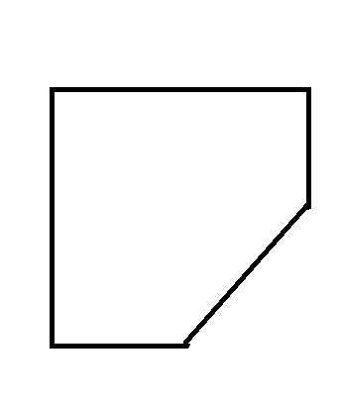

Counterexample: 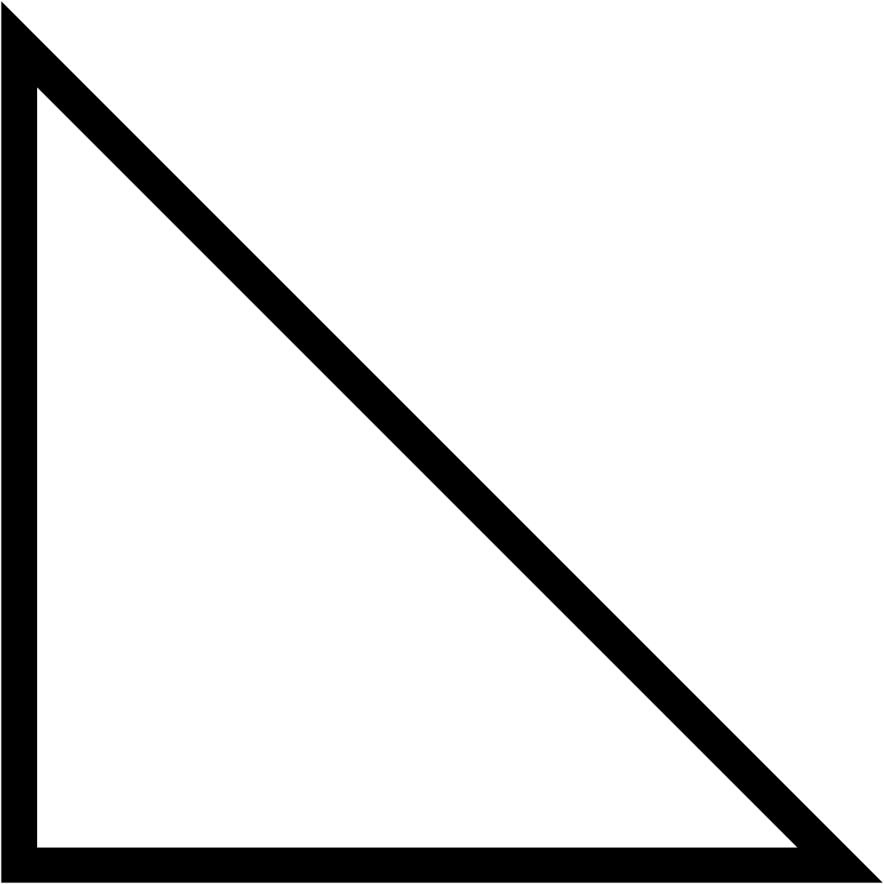

Explanation: When you cut a corner that is smaller than half of a square off, it will make a pentagon but, when the corner is exactly half of a square, it will make a triangle.

- ‘A cuboid has 2 square faces.’

Sometimes. This question can be proved right and wrong.

Example: 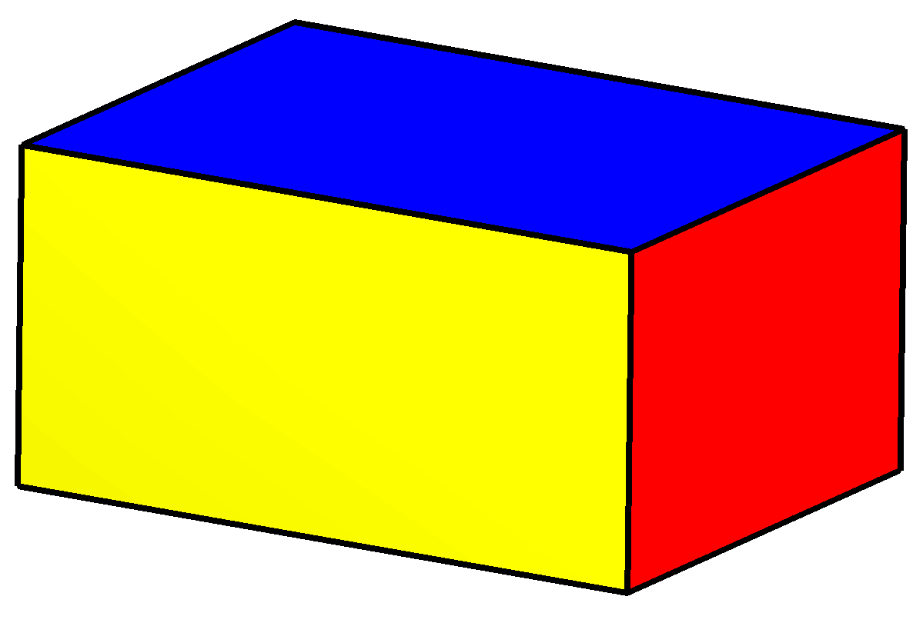

Counterexample: 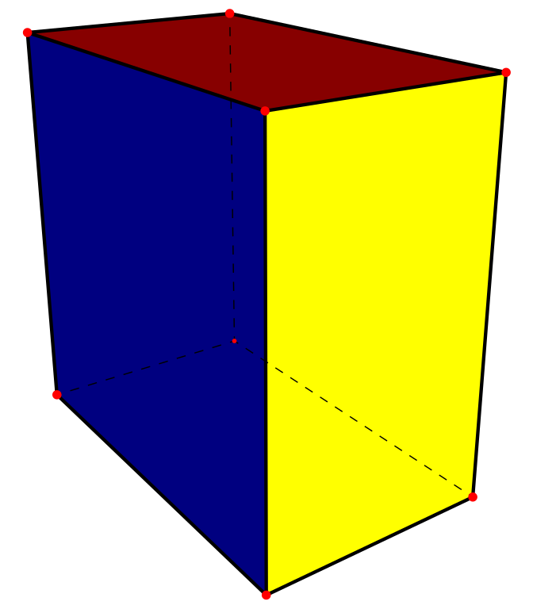

Explanation: A cuboid can have 1 set of square faces, or it can have no square faces but, it cannot have 2 sets of square faces without having a third. On the other hand, it can have 3 sets of square faces, making a cube which is also a cuboid.

- ‘When you cut off a piece from a 2d shape you reduce the area and perimeter.’

Always. This question cannot be proved wrong.

Example: 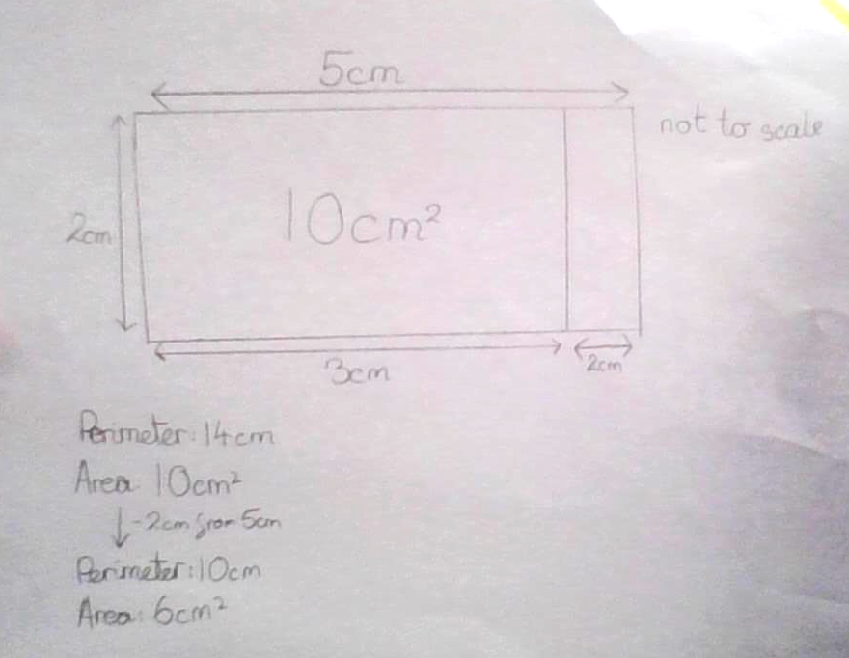

Explanation: When you cut off any part from a 2d shape, the perimeter will always be lessened. As a result of this change, the area will also decrease because the area is the base times the height and -for a triangle- divided by 2. This can never be different because you can never increase by taking away.

- ‘Triangles tessellate.’

Always. This question can only be proved right.

Examples: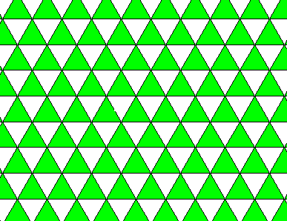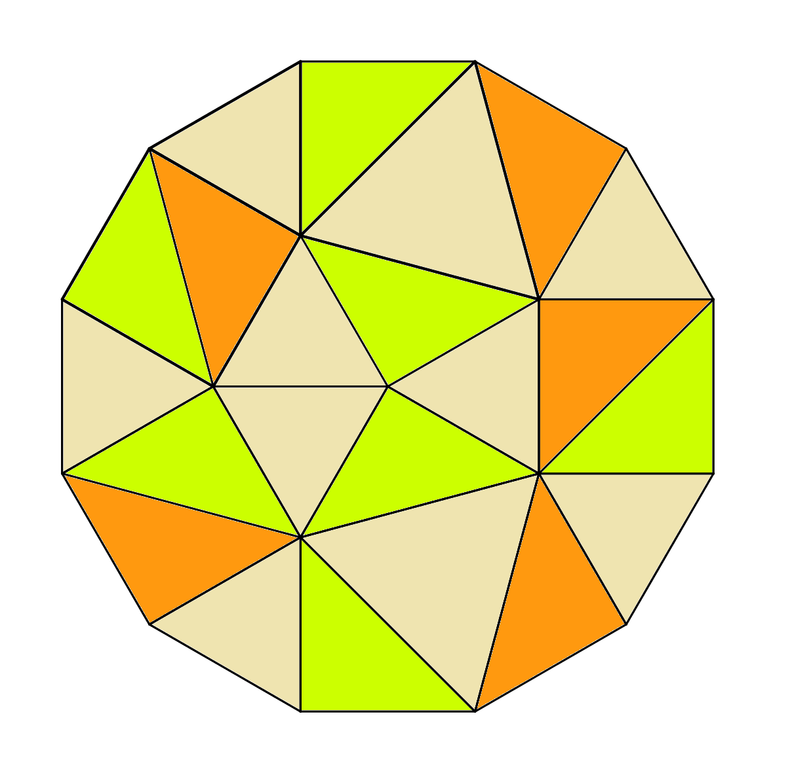

Explanation: Triangles can always be used to tessellate, in other words cover a surface, even if they are not the same type of triangle. In the second picture above, there are 2 different types of triangles and they are still tessellating. It is impossible to have triangles that do not tessellate.

- The number of lines of symmetry in a regular shape is equal to the number of sides.’

Always. This question cannot be proved wrong.

Examples: 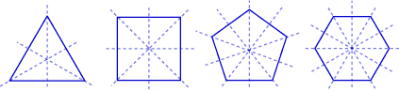

Explanation: In a regular 2d shape where the number of sides are odd, you have to count the vertices and that is how many lines of symmetry you have. In a regular 2d shape where the number of sides are even, you have to count up all the pairs of opposite sides and add that number to the number of vertices. As the sides will all be equal, the number of vertices and sides will be the same.

- ‘Quadrilaterals can be cut into 2 equal triangles.’

Sometimes. This question can be proved right and wrong.

Examples: 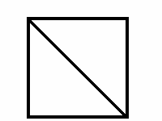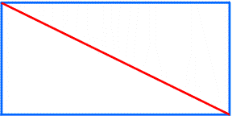

Counterexample: 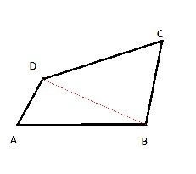

Explanation: In a regular quadrilateral, the shape can be cut in half diagonally to make 2 equal triangles. In an irregular shape however, the sides are all different so it is impossible to make 2 equal triangles from this sort of shape.

