Nrich fraction challenge
First, we worked out the fractions for the numbers e.g 9 is ¼

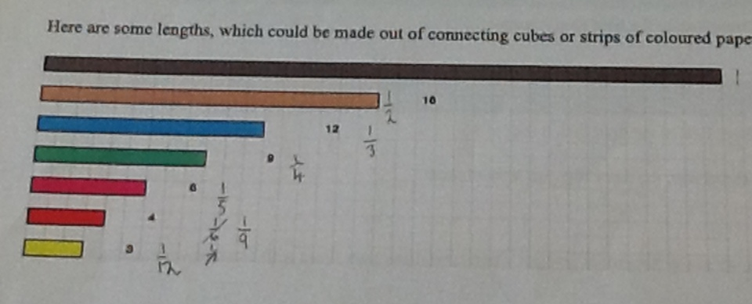

Then we looked at diffirent ways to use the other bars to equal 36 as one whole. Our first soloution was this …
The way we worked this out was 18+9=27 and then 27+3=30 and the only number left to add was a 6. You could have done 3+3 but we decided to use a 6. So 30+6=36.
After that we started to look for the next souloution but we didn’t want to use 18 again straight the way so we tried using high numbers below 18 .The first one we thought of was 12 so we did 4+12+4+12+4=36. Here is our way of showing our second souloution .

The way we worked this out was 12 + 12 is 24 and then 4 + 4 + 4 is 12. One 1/3 of 36 is 12 so you need 3 lots of 12 to make 36.
In our soloutions, 9 hasn’t been used a lot so we thought we could include 9 a little more, so here is our next souloution.
The way we worked this out was 9+6=15 then we added 3 which makes 18. After that we added another 9 which made 27. From here ,there was only 9 spaces left to fill so we used a 6 and a 3 which made the final answer 36.
We used normal numbers instead of fractions because it made it easier to explain.We did have more souloutions but these are the ones that made the other ones easier to work out.
By Jess ,Eva-Lilly and Cordelia.

