Fraction lengths investigation

First we looked at the instructions for the investigation. Next we made a key to remember all of the fractions e.g. 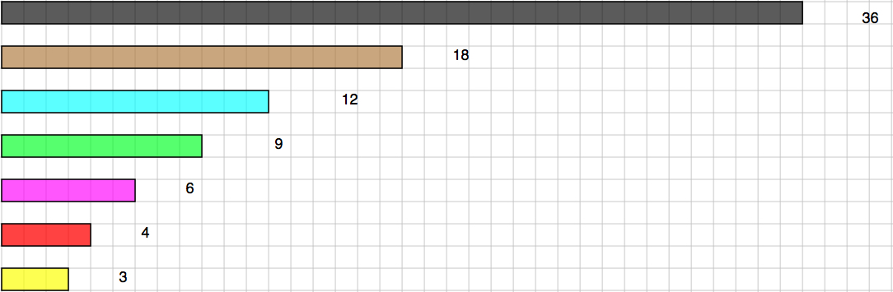
36 = 1, 18 = ½, 12 = 1/3, 9 = ¼, 6 = 1/6, 4 = 1/9, 3 = 1/12
After that, we found some the possibilities to make the 36 with each of the other fractions e.g.
½ + ½ = 36 or 1 whole 4/6 + 2/6 = 36 or 1 whole
2/3 + 1/3 = 36 or 1 whole 4/9 + 2/9 + 3/9 = 36 or 1 whole
¼ + ¼ + 2/4 = 36 or 1 whole 4/12 + 5/12 + 3/12 = 36 or 1 whole
Then we looked at the combinations that we had and used them to make more e.g.
½ + ½ = 2/2 or 1 whole 4/6 + 2/6 = 3/6 + 3/6
2/3 + 1/3 = 1/3 + 1/3 + 1/3 4/9 + 2/9 + 3/9 = 5/9 + 4/9
¼ + ¼ + 2/4 = 2/4 + 2/4 4/12 + 5/12 + 3/12 = 7/12 + 5/12
Finally, after an hours work, we checked through all of the combinations and luckily they were all correct. We also found out that sometimes you can get more possibilities than the denominator.
Moving on…
We then had had to do the next part of the sheet and pick four numbers and put them together to then see if it would be a mixed fraction or under the 36 (most of them were mixed fractions.)Then we looked at the examples on the sheet and tried to work out what to do without the explanation that it gave us for the task because at the start we didn’t really get what we were supposed to do. We did our calculations and found out first that 3, 6, 12 and 18 was the same as 1 and 1/12
This example shows two 1/3’s and two 1/4’s which is the same as 1 and 1/6.
Finally we looked at all of the fractions and made all the possibilities that we could find.
Reina and Sienna, Year 5

