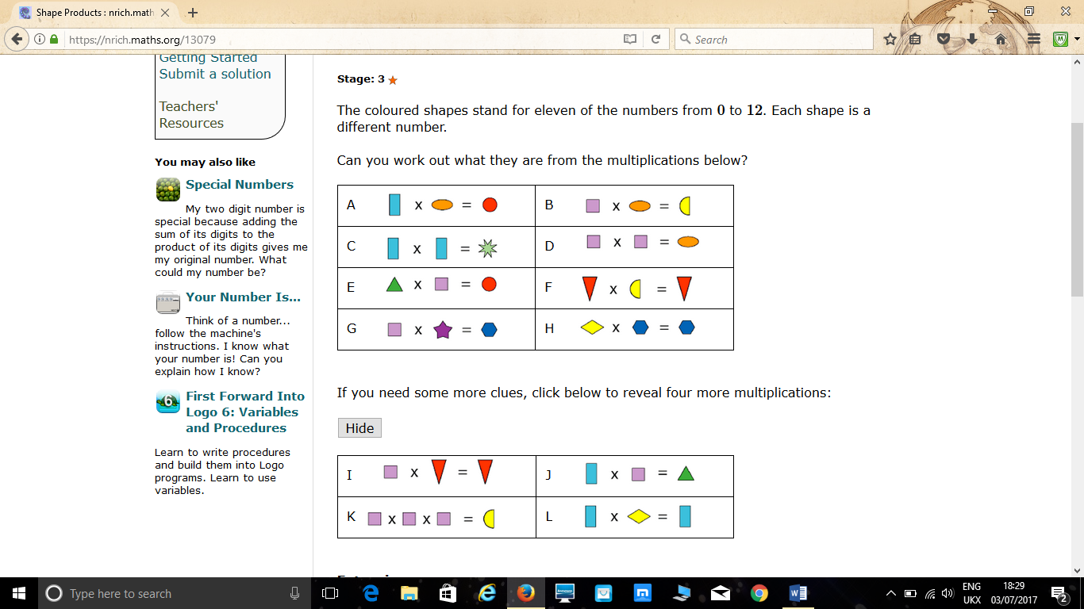

I started by determining the value of the in F – the only digit that can be multiplied by any other and remain the same is 0. Therefore, = 0.
However, we need to also recognise that there is another possibility – the semi-circle in equation F can also equal 1 as any number multiplied by one will be itself (x multiplied by 1 is always x).
The same is true for equation H (the definitely hexagon either equalling 0 and the rhombus having a value of 1). Either way, we can conclude that the values for both 0 and 1 are taken in those two equations.
Next, we can determine the values of the orange ellipse and green octagram by first noticing that they are both square numbers (as two of the same shapes are multipled together e.g. two squares are mutliplied to give the orange ellipse). The possible square numbers between 0-12 are 1,4 and 9. However, both annot have a value of 1 because it is already taken as mentioned above. Also, if they did have a value of one, the shapes would all have to be the same (1x1=1).
We can ascertain that =4 and not 9 because otherwise equations A andB would not hold true (without the rectangle and square equalling 0 and 1, which we already know is not possible) as the value is too large. This therefore means that: = 2 (square root of 4), =9 and =3 (square root of 9).
Then we can work out the value of =12 (3X4) from equation A and =8 (2X4) from equation B. We can also determine that = 6 from equation E (12 divided by 2).
If the yellow semicircle = 8, in equation F, must equal 0 as any number multiplied by 0 is 0 and if it were 1, the answer (1x8=8), would be a yellow semicircle. This means that =1 in equation H because any number multipled by 1 is itself and we have determined that the blue hexagon cannot be 0 as it is already taken.
To determine the values of the purple star and blue hexagon using equation G, we use the information that the hexagon must be an even number (as the square=2 and all multiples are even), and the only even number from 0-12 which has not been assigned is 10. Therefore, =10 and =5 (10 divided by 2).

