KEY
Blue Rectangle = BR, Orange Ellipsis = OE, Red Circle = RC, Pink Square = PS, Yellow Semi Circle = YSC, Green Star = GS, Green Triangle = GT, Red Triangle = RT, Purple Star = PSR, Blue Hexagon = BH, Yellow Diamond = YD
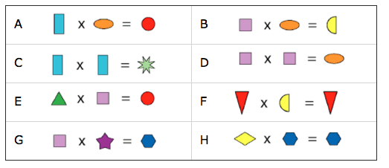
0-12

A.BR x OE = RC
Therefore
RC is bigger than both BR and OE so in order of size (so far)- BR and OE, RC

B.PS x OE = YSC
Therefore
YSC is bigger than both PS and OE so in order of size (so far)- BR and OE and PS, RC and YSC

C. BR x BR = GS
Therefore
GS is BR squared. BR cannot be higher than 3, for 4 x 4 = 16, or lower than 2 for 1 x 1 = 1, which is impossible given the rules. GS cannot be higher than 9 as a result.

D.PS x PS = OE
Therefore
OE is PS squared. PS cannot be higher than 3, or 1. It also cannot be 3 for that would make statement B equal 3 x 9 =27, which is impossible given the rules. Therefore PS = 2. This also means that BR = 3, for it cannot be higher than 3 or 1, as stated earlier. This would also mean that GS = 9 and OE = 4, for PS=2. As a result, we can solve RC, for BR (3) x OE (4) =12, and YSC, for PS (2) x OE (4) = 8

So far, we have PS=2, BR=3, OE=4, YSC=8, GS=9 and RC=12

E.GT x PS= RC.
Therefore
2 x GT =12 -> GT = 6

F. RT x YSC = RT
Therefore
RT x 8 = RT, so RT must equal 0, for no other number within the range works. RT=0

G.PS x PSR = BH
Therefore
2 x PSR = BH -> 2 PSR =BH
BH cannot be 12, 8. PSR cannot be 3, for 3 is already being represented by BR. Therefore, BH can also not be 6. Therefore, BH=10 and PSR =5

H. YD x BH = BH
Therefore
YD x 10 =10
10 divided by 10 =1
Therefore, YD=1

In Conclusion
RT=0, YD=1, PS=2, BR=3, OE=4, PSR= 5, GT=6, YSC=8, GS=9, BH=10 and RC=12

