Shape products:

A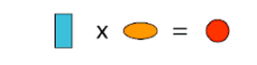 | B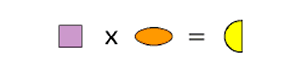
C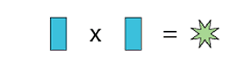 | D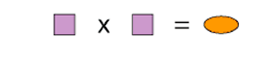
E | F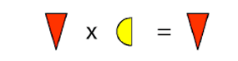
G | H
To work out this method we had to start off by working out what the blue octagon by looking at source H. This is because the answer is the same as one of the multiples. From here we moved on to source G because that too has an octagon. We found these answers…
Octagon= 5
Equilateral triangle= 6
Rectangle=3
Star=5
Green star=4
Circle=12
Isosceles=0
Oval=4
Square=2
Semi-circle=8
Hexagon=10
Diamond=1

