Shape Products

Stage: 3

The coloured shapes stand for eleven of the numbers from 0 to 12. Each shape is a different number.

Can you work out what they are from the multiplications below?

A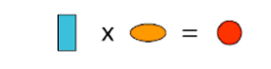 | B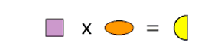
C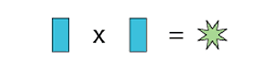 | D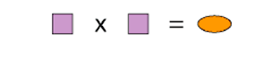
E | F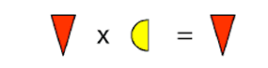
G | H

I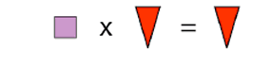 | J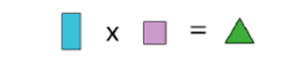
K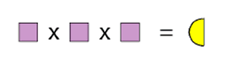 | L

Lets write it all in Algebra using the starting letter of the shape to put it in an equation. IT = Isosceles Triangle
HC = Half Circle
ST = Star
PS = Purple Star

R*O = C
S*O = HC
R*R = ST
S*S= O
T*S= C
IT*HC = IT
S*PS = H
D*H = H
S*IT = IT
R*S = T
S*S*S = HC
R*D=R

The Yellow Diamond has to be 1 as the equation D*H = H and D*R = R shows it. If it was zero then both equations would equal D as anything times zero is zero.
The Red triangle is 0 looking at the 2 equations it is in. It equals itself at all times.
In terms of the Square, the Oval is S squared and the half circle is S cubed. So S can be 2 as it is the only cube apart from 1 that's under 12.
The Oval is 4 and the Half circle is 8 when the Square = 2. If it was 3 it would be 3,9,27. 27 won’t work.
The Blue Rectangle has to be 3 because 3 and 4 makes 12. This is the Blue rectangle*Oval. We can’t go above and 1 and 2 are already used by other shapes.
So the Circle is 12 as the rectangle*oval = circle. So 4*3 = 12.
Then the green triangle is 6 as 12/2(Circle divided by square) = 6.
The light green star is 9 as the Blue Rectangle squared makes the star.
We left with 5,10,7 and 11. We need 2*_=_ and 5 and 10 fit in.

So we have:
0 - Red Triangle
1 - Yellow Diamond
2 - Square
3 - Blue Rectangle
4 - Oval
5 - Purple Star
6 - Green Triangle
8 - Half Circle
9 - Light Green Star
10 - Blue Hexagon
12 - Red Circle

Extension
Once you have worked out the value of each shape above, take a look at the two multiplications below:

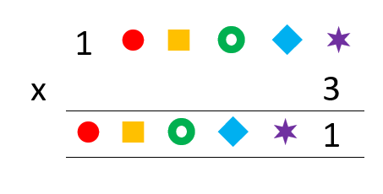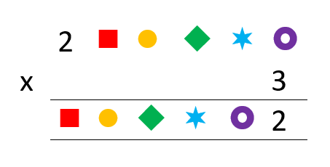
Can you work out the value of the shapes in each product?
1:
We can tackle this by carry forwarding the 10s digit of each multiplication into the units of the next to make it all weak. We can only put 7 in the first one but need 5 more from the units of the next to make 7. We can carry on with this method until we form the whole equation.

The Purple star has to be 7 because 7 is the only number in the 3 times table to give a units of 1. We have 2 in the tens and need 5 more.
The Blue diamond needs to be 5 because 5*3 = 15. The units becomes 7 with 5+ the existing 2.
The Green circle has to be 8 because 24 has 4 in the units. 4+1(Tens of 15) = 5 which is the blue diamond.
The square is 2 because 3*2 = 6 6+2 =8 which = Green circle.
The Red circle is then 4 because 4*3 gives a unit of 2. 1*3 +1 makes 4.

We get a sum of:
142857
* 3
= 428571

2:
Using the same method as before.
We can put 4 in the purple circle. 4*3 = Unit 2 with a carry forward of 1.
We can put 1 in the star. 1*3+1 = 4. We add 1 from the 10s digit of 4*3.
We can put 7 in the green diamond. 7*3 = Unit 1.
We can put 5 in the orange circle. 5*3 + 2 = Unit 7. We add 2 from the tens of 7*3.
We can put 8 in the red square. 8*3+1 = 5 which works.

The Equation all adds up and is equal.
The Multiplication is:
285714
* 3
857142

