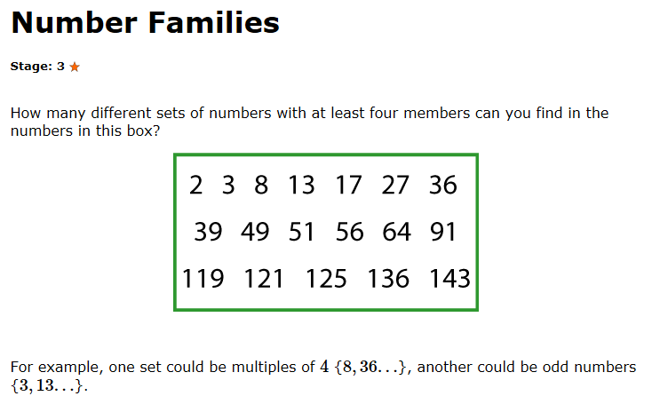
Multiplies of 2:
2, 8, 36, 56, 64, 136
Multiplies of 3:
3, 27, 36, 39, 51
Multiplies of 4:
8, 36, 56, 64, 136
____________ Not enough numbers for this family
Multiples of 5
____________ Not enough numbers for this family
Multiples of 6
Multiples of 7:
We found 9 different families, but we think that there are more to discover can you find them? By Molly, Keira and Daisy
49, 56, 91, 119
Multiplies of 8:
8, 56, 64, 136
Odd:
3, 13, 17, 27, 39, 49, 51
Even:
2, 8, 36, 56, 64, 136
Squared:
36, 49, 64, 121
Prime:
2, 3, 13, 17

