How we solved Alison’s Quilt
We worked as a team to solve this problem by using grids, tables and squares that match the area and perimeter of Alison’s quilt. Our first step to solve this problem was to read the question thoroughly and made sure that we understood it then, we cut out all of the dimensions that were on the list. After that, we tried to puzzle them together like a jigsaw placing them in different positions until we made a perfectly rectangular shape that didn’t have any gaps. We worked out the area, perimeter and dimensions of the entire shape which were:
Area: 3,055cm squared
Perimeter: 620cm
Dimension: 47x65 = 3,055cm squared
Then we recorded everything down in our books by writing it down in a table. We also took photographs of our fitted rectangle for proof.
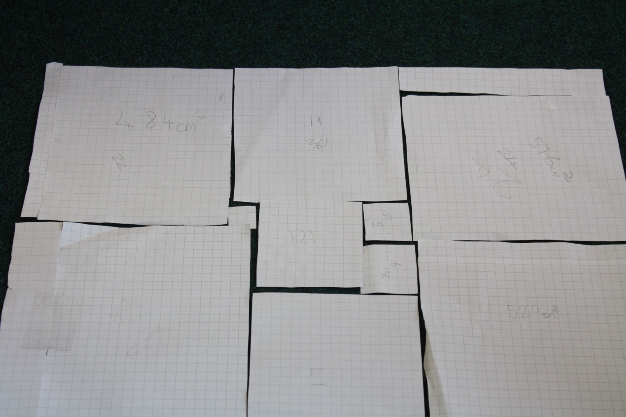

By Nikki and Mollie (Year 6)

+

