How we did Alison’s Quilt
To make the first square we cut out the little squares and put together the large one. It took a few tries but it is possible. After we had completed fitted and found that the dimensions were 33 down 32 across and the area is 1056 cm squared, we cut out the other squares to make Alison’s Quilt. It took a lot of attempts but we found that the dimensions are: 47 down and 65 across. We divided 3055 (the total area) to try and search for a whole number until we got a possible answer. After that, we tried to make the square and we found out that it is possible.

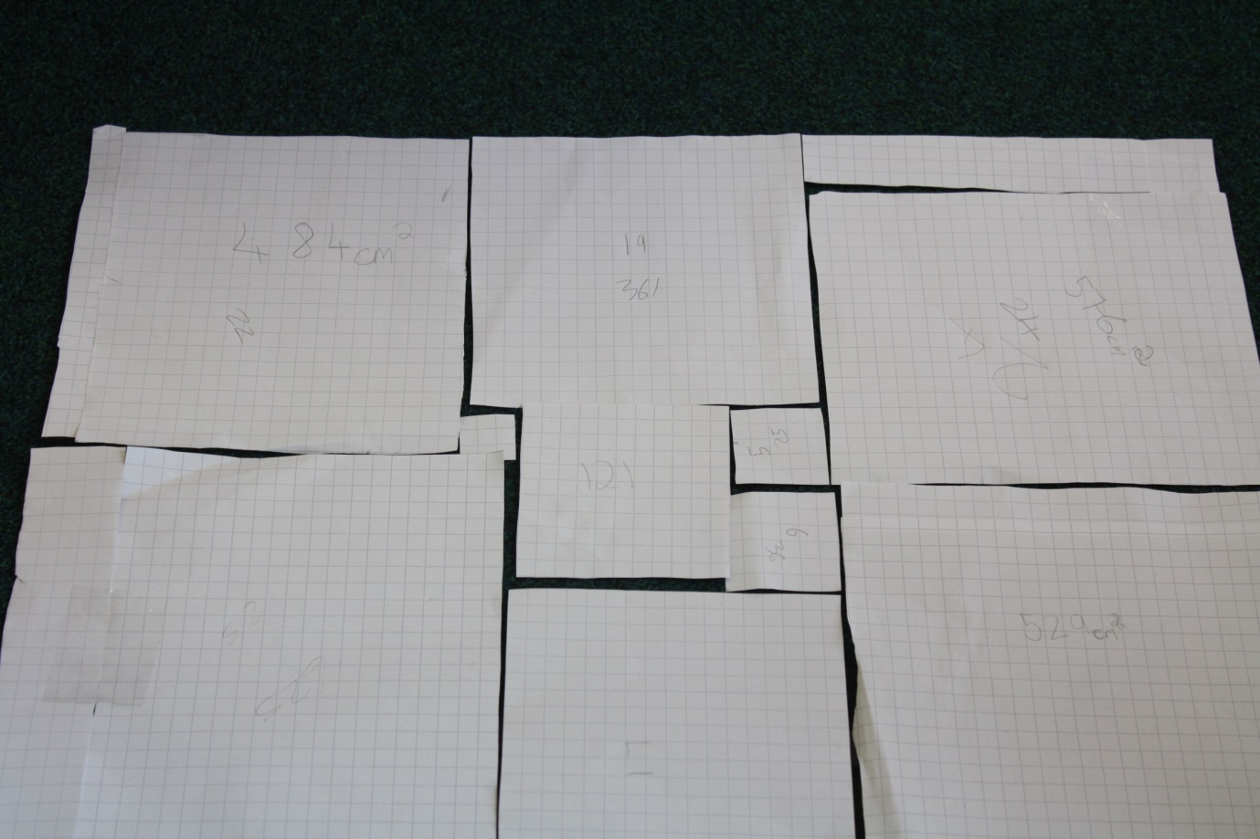

By Laila, Lucy and Alice (year 6)

