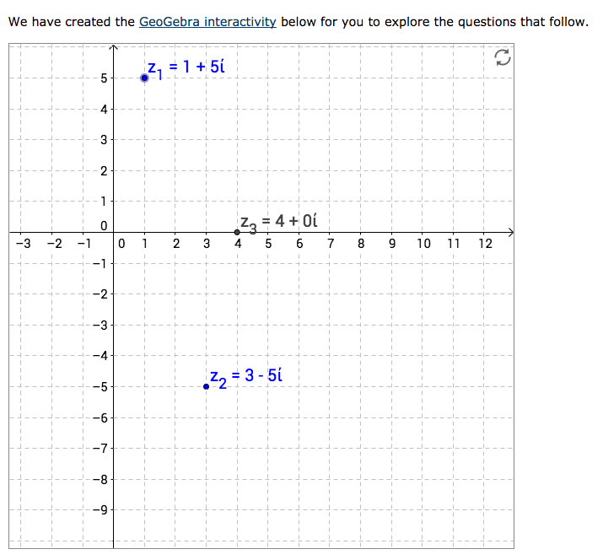
Something which I found interesting about this exercise was thinking about the complex numbers as vectors. I've read that complex numbers can be seen as position vectors, and therefore the addition of two complex numbers should produce a resultant vector. Here’s my (badly) drawn attempt at showing this. The Argand diagram is the same as any other number plane, and vectors are added using the same methods. The method I have shown is the parallelogram method, but I recognise that for this task you just wanted an algebraic explanation. But, I love diagrams, so this is a mixture of both.

Away from the diagram then, you can see that the first complex number is 1 + 5i. The second is 3 – 5i. Very simply, we can see that adding these two complex numbers will give just a real number, 4, as the 5is cancel. Boring!

This is why I thought I’d just try and get people to think about complex numbers and the complex plane as being no different to the Cartesian plane – don’t be scared because there is only one real axis! When you add two vectors on the Cartesian plane, you add the two separate components (you add the x-coordinates together and the y-coordinates together). That is all we are doing here. The two x-coordinates are 1 and 3 1 + 3 = 4. The y-coordinates are -5i and 5i -5i + 5i = 0.

I have repeated the same thing a few times above me, but I think it is important when reading into a topic in Mathematics to be able to link different related topics together.

