To make a complex number equal a real number, you must make the coefficient of i total 0. Using only addition and subtraction, this can be achieved by making d = -b in the expression (a+bi) + (c+di). This would make the coefficient of i equal 0 , making i also equal 0.
Eg. (4+2i)+(5-2i) = 9+0i = 9
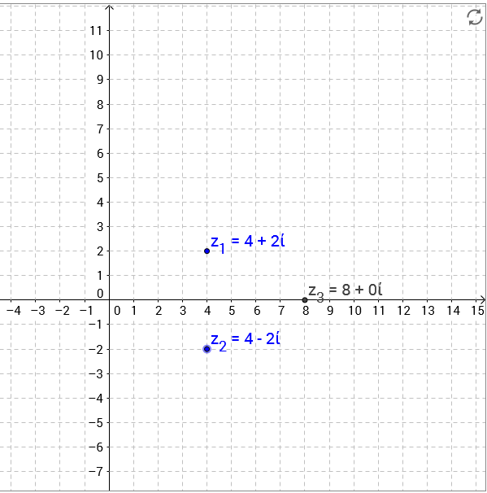
To make a complex number an imaginary number, you must make a = 0 in the expression a + bi. This can be done by making a = -c or c = -a in the expression (a+bi) + (c+di).
Eg. (4+8i) + (-4+9i) = 0 +17i = 17i

