Mapping the Territory

I have found that when multiplying two complex numbers, in order for their product to equal a real number, the points must be situated on lines that are reflected in either the x or the y-axes, making the gradients the inverses of each other:
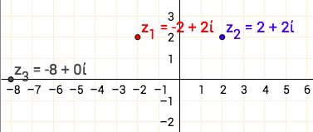
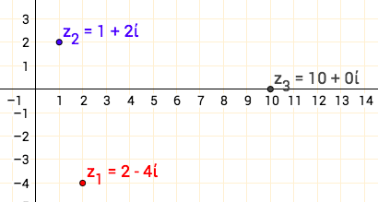
Im
Im

Re
Re

Fig 2

Im
Fig 1
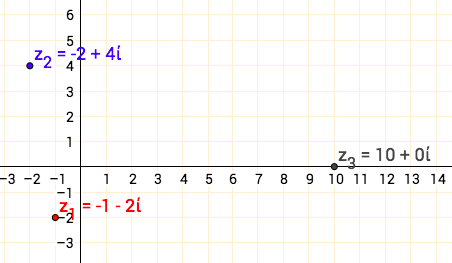
For example, on the diagram above, z₁ is on the line $y=-2x$ and z₂ is on the line $y=2x$. The gradients are the inverses of each other and the product of the two complex numbers is a real number.
Re

Fig 3

Consider complex numbers $z_{1}=a+bi$ and $z_{2}=c+di$

$$z_{1}z_{2}=\left(a+bi\right)\left(c+di\right)$$

$$=ac+adi+cbi+bdi^{2}$$

$$=\left(ac-bd\right)+\left(ad+cb\right)i$$

$$Im(z_{1}z_{2})=ad+cb=0$$

$$\frac{a}{-b}=\frac{-c}{d}$$

By noting this relationship between a, b, c and d, you can find that complex numbers, when multiplied by each other, equal a real number provided they are on lines that are reflected in either the x or y-axes.

If we want an imaginary number as the product of z₁z₂, the lines on which the numbers are positioned must be reflected in the line $y=x$ or $y=-x$ as seen in the diagrams below:

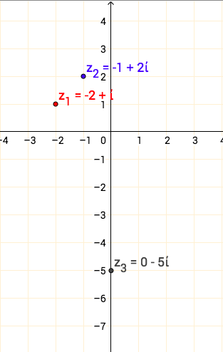
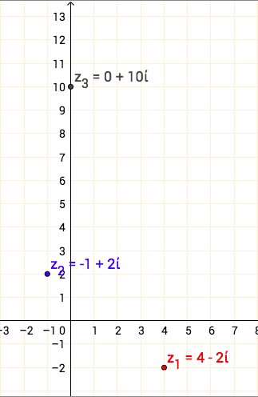
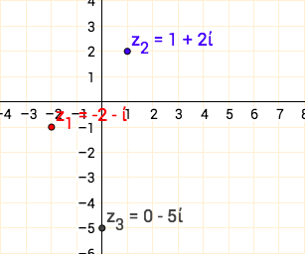
$$y=-x$$
Re
Re
Re
Im
Im
Im
Fig 6
Fig 5
Fig 4

In this case:
$$z_{1}z_{2}=\left(a+bi\right)\left(c+di\right)$$

$$=ac+adi+cbi+bdi^{2}$$

$$=\left(ac-bd\right)+\left(ad+cb\right)i$$

$$Re\left(z_{1}z_{2}\right)=ac-bd=0$$

$$\frac{a}{b}=\frac{d}{c}$$

