Into the Wilderness - solution

For which values of $z_{2}$ does the line through $z_{1}$ and $z_{3}$ pass through the origin?
I have found that when $z_{2}$ is a negative real number, the line through $z_{1}$ and $z_{3}$ passes through the origin.
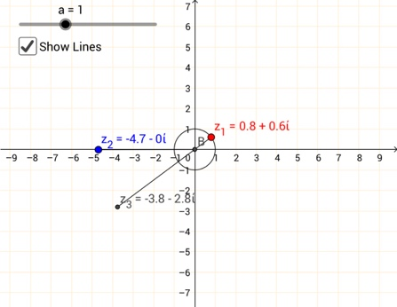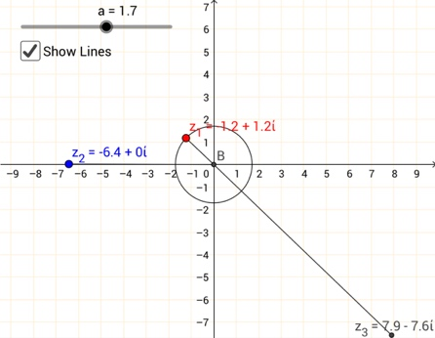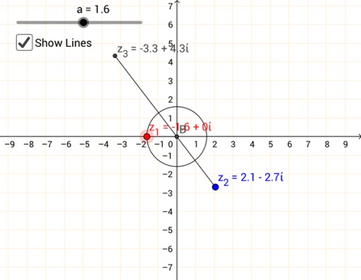

Note: when $z_{2}$ is a positive real number, if you were to extend the line through $z_{1}$ and $z_{3}$ it would pass through the origin.

What is special about the positions of $z_{1}$ for which $z_{2}$ and $z_{3}$ are equidistant from the origin?
I have found that when $z_{1}$ is a distance of 1 unit away from the origin, $z_{2}$ and $z_{3}$ will be equidistant from the origin.
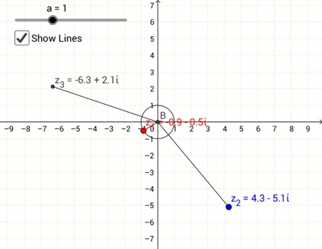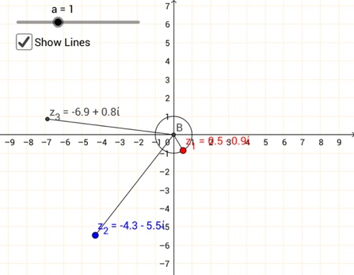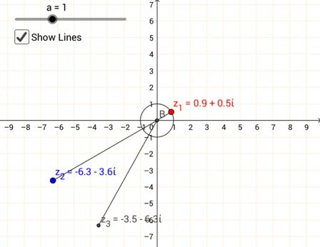

Multiplying by real numbers
I have found that when multiplied by a real number, the complex (non-real) number and $z_{3}$ can always be joined by a straight line.

When multiplying by positive real numbers, the line through the complex number and $z_{3}$ extends outward from the origin in a straight line.
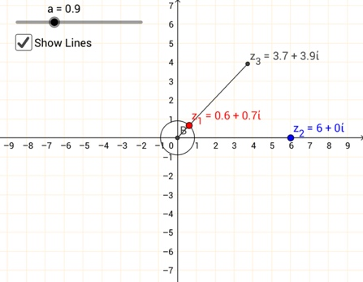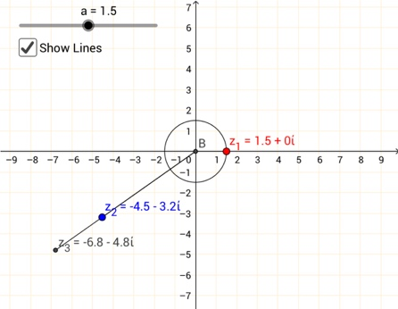
When multiplying by negative real numbers, the line through the complex number and $z_{3}$ passes through the origin.
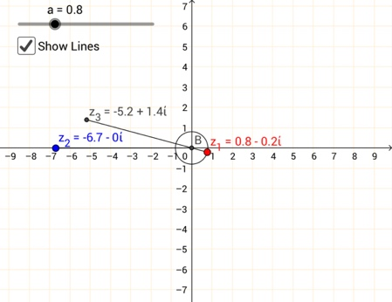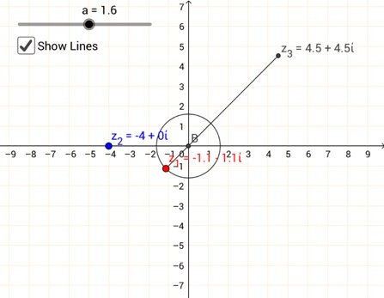

Multiplying by imaginary numbers
I have found that when multiplied by an imaginary number, the complex (non-imaginary) number and $z_{3}$ are always perpendicular to each other.

When multiplied by a positive imaginary number, the complex number will be 90° clockwise from $z_{3}$.
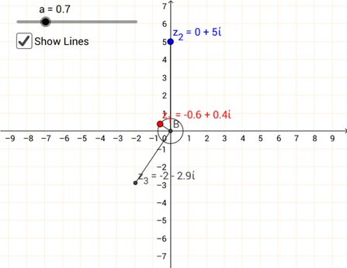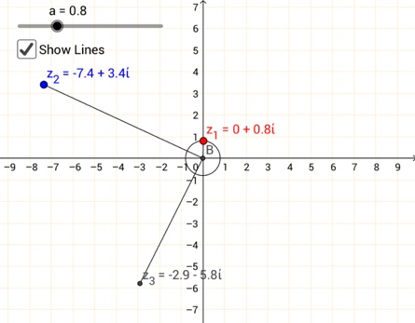
When multiplied by a negative imaginary number, the complex number will be 90° anticlockwise from $z_{3}$.
