My solutions to Swimming Pool Tiles by Lois (Stourport Primary Academy Y6)
I decided to colour all the multiples of 9 on the different sized grids. I noticed that if you join all the numbers with lines (so you would join 9 to 18, then 18 to 27 and so on), there is a pattern where it makes a spiral of shapes. It goes from a triangle to a square to a pentagon and so on so the shapes within the spiral increase by 1 corner each time.
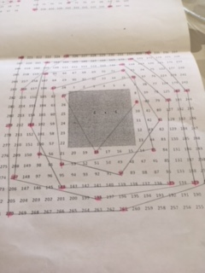
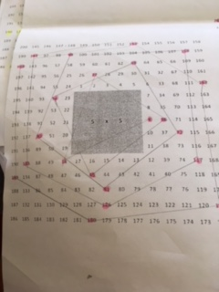
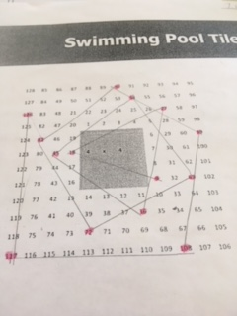
Here are the photos of my work to prove it!

Originally I had made a prediction that odd numbered times tables wouldn’t have a pattern. I was wrong!

