Swimming Pool Tiles by Keira (Y6 Stourport Primary Academy)
Most of my friends said that there isn’t a pattern for the 5 x-table but I thought you could group the highlighted numbers together and make petals on a flower like this.
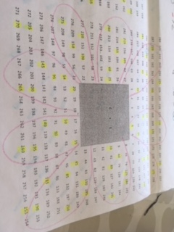
My group had a go, with help from our teacher, at working out how you could predict how many tiles would be needed to go around different pool sizes.
One of my friends spotted that if you multiply the area of the pool by 8 you get the number of tiles needed to go around it.
For example if the pool is 3 x 3 you would do 3x3=9 then multiply 9 by 8 which gives you 72 tiles. We checked this with all the tiles on the sheet and found this to be true. Then we used the same formula to calculate how many tiles would surround a pool that 100 x 100.
100 x 100 = 10000.
10000 x 8 = 80000. We decided not to have a go at drawing that one!

