Daisy (Y6 Stourport Primary Academy)

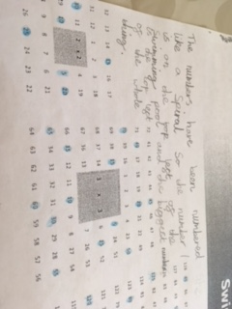
The following photos show some of the patterns I discovered when I tried the Swimming Pool Tiles problem.
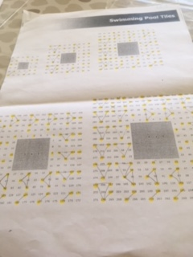
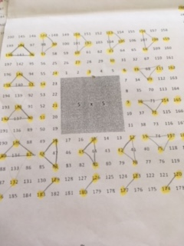
I couldn’t see an obvious pattern to the 5 times table, but once I had highlighted all the numbers in the 3 times table I noticed that you could join these up in groups of 3 to make a pattern or rotating triangles. Here’s a close up to show you what I mean.

After I had completed this I wondered why there was this obvious pattern of triangles with the 3 x table but no obvious pattern with the 5 x table. I wonder whether there would be a clearer pattern if I tried the 5 x table on a bigger grid?

