Angles Inside
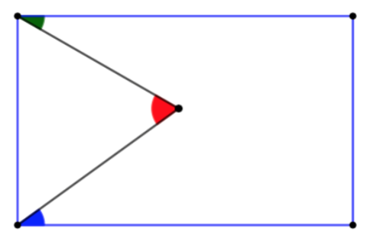
Let’s call the green, blue and red angle: g, b and r, respectively.

Sum of Interior Angles in a Pentagon:

- 180°(n-2) = sum
180° (5-2)=sum
180°*3 = 540°
- Each angle between two perpendicular sides, by definition is 90°. Therefore, we know 2 of the angles in the pentagon are each 90°
- Reflex on opposite side of point where r is located = 360° - r
- 540° = 180° + g + b + 360 – r
0 = g + b – r
r = g + b

Sum of Interior Angles in a Triangle:

- The sum of angles in a triangle = 180°
- The base angle of the triangle next to g = 90° - g, The base angle of the triangle next to b = 90° - b
- 180° = r + 90 – b + 90 – g
180° = 180° + r – g – b
0 = r – g – b
r = g + b

Alternate Angles:
----------------
- Create a perpendicular bisector through r
- This creates 3 parallel lines
- As alternate angles are equal, r = g + b

Parallelogram and Trapezium

- Co-interior angles sum to 180°
- The base angles in the triangle sum to 180°- g – b
- The sum of angles in a triangle = 180°
- 180° = 180° - g - b + r
0 = r – g – b
r = g + b

