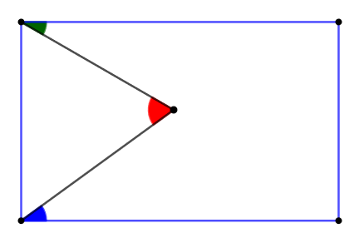
a
c
b
b
c
a
Allison’s conjecture must be true.
I know that if you draw a line through a set of parallel lines, the opposite angles will be equal, and the same on all the set. Therefore, if you draw a line parallel to the horizontal line, you will see that a c must be the sum of a and b.
The angles with the arrows pointed at them have angles equal to each other, the ones without do too.
ab
b
a
This will always be the case, so Allison is right.

