Pocket money

Without doing any working out, which one would you choose, and why?
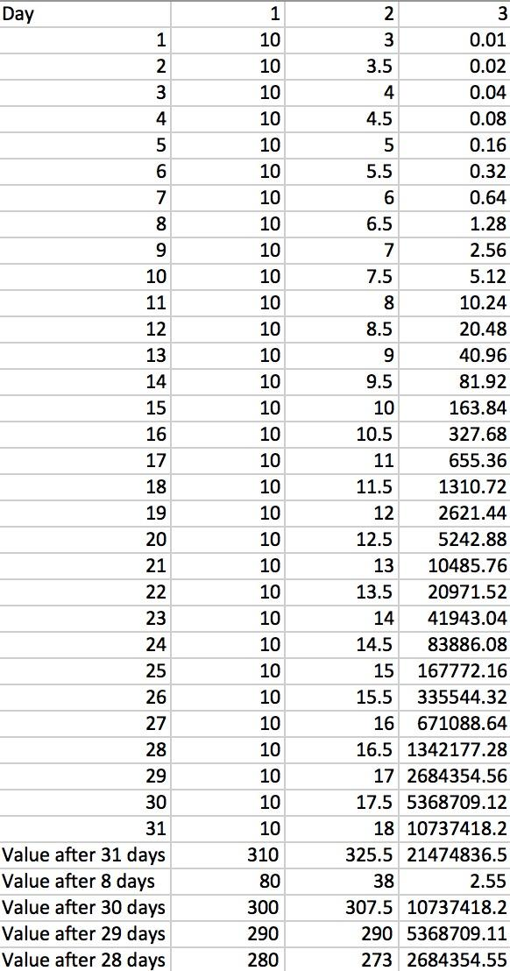
I would choose the third option because it means the value of money you get each day will increase exponentially, and even though you start off with very little money it will probably become the most rewarding.

In a month with 31 days, how much money would you have by the end of the month, under each system?
After making a spreadsheet here are the results:
-For the first option you would get a total of 310 dollars.

-For the second option you would get a total of 325.5 dollars (the amount of money you would get each day can be found with the formula: 0.5 x day + 2.5),

-For the third option you would get a total of 21,474,836 dollars (the amount of money you can get each day can be found with the formula: 0.01 x 2^{(day-1)}.
I knew you would get a lot of money from the third option but I didn’t expect it to be this much…. On second thought, the third option may not be very good, as I would not like my parents to go bankrupt due to giving me all their money.

In which months would option 1 be better than option 2?
I used excel again to find the total value of all the pocket money after 30, 29, and 28 days. After 28 days the value of the money you get from the first option is more than the second, this only applies to the month of February.

If your family stopped your pocket money on day 8, which option would give you the most?
Using excel… again, I have found that the first option is definitely the most rewarding if you only got pocket money for 8 days, with 80 dollars compared to 38 and 2.55 dollars.

On which day of the month does option 3 become the most fruitful?
The last day, because you get the most money on that day.

If you choose option 3, how many days would it be before you became a millionaire?
On the 28th day you get a million dollars, therefore on the 27th day the sum of all the pocket money you have received will total over a million. This is because on day n you get 0.01 x 2^{n} dollars, on day n + 1 you get 0.01 x 2^{n} x 2 dollars, if you add them together you get 0.02 x 2^{n} x 2, on day n + 2, you get 0.01 x 2^{n} x 2 x 2 dollars, or 0.02 x 2^{n} x 2. Since the money you get on days n and n + 1 = the amount of money you get on n + 2, the value of money you get on day n + 3 should equal the sum of the money you got on days n and n+ 1 and n + 2. This pattern repeats.

