For each pattern, can you find a sequence of fractions whose sum represents the blue area?

Each rectangle is half the area of the larger square around it. Each new ring has 1/4 of the area of the ring before it. This produces a geometric sequence with a = 1/2 and r = 1/4. So the sequence of fractions whose sum represents the blue area is 1/2 + 1/8 + 1/32 + 1/128 + 1/512 + ...

For each pattern, can you find different ways to work out the total proportion shaded blue?

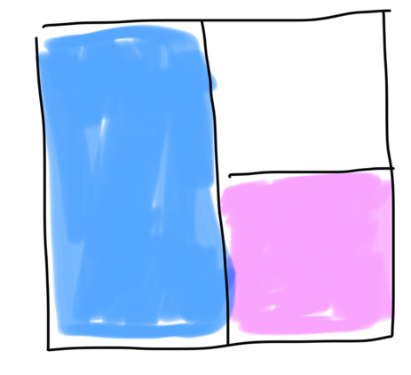
This shows the outer ring of the pattern. The blue rectangle is twice the area of the pink square, so there is twice as much blue as pink - 1/3 of the area is pink and 2/3 is blue. The same will be true for each ring added, therefore the overall pattern has twice as much blue as pink.

Since the sequence of fractions whose sum represents the blue area is a geometric sequence, we can check this by summing the sequence to infinity, which will give the total blue area if the pattern continued forever, and should be the same as the above value for area. Sum to infinity = a/(1-r) = (1/2)/(1-1/4) = 2/3.

For each pattern, can you find a sequence of fractions whose sum represents the blue area?

In this pattern, each smaller blue square is 1/4 of the area of the larger square before it. Now we just need to find the area of the first blue square. Side length is 1/2 of the larger square so 1/2 x 1/2 = 1/4. So the sequence of fractions whose sum represents the blue area is: 1/4 + 1/16 + 1/64 + 1/256 + ...

For each pattern, can you find different ways to work out the total proportion shaded blue?
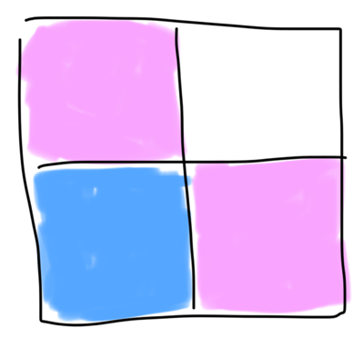
This shows the outer ring of the pattern, in which there are two pink squares and one blue square. Since all the squares have the same area, the blue square is 1/3 of the total area. The same will be true for each ring added inside, therefore 1/3 of the overall pattern is blue. We can check this again by summing our geometric sequence to infinity: (1/4)/(1-1/4) = 1/3.

For each pattern, can you find a sequence of fractions whose sum represents the blue area?

In this pattern, each blue L shape is 4/9 of the area of the square around it. Each smaller ring is 1/9 of the area of its larger ring, so the area of each smaller L shape is 1/9 of the area of its larger L shape. So the sequence of fractions whose sum represents the blue area is: 4/9 + 4/81 + 4/729 + …

For each pattern, can you find different ways to work out the total proportion shaded blue?
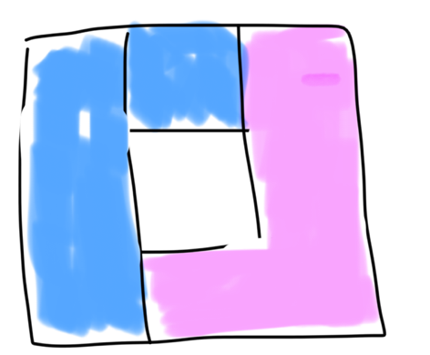
This shows the outer ring of the pattern. 3/8 + 1/8 = 4/8 = 1/2 of the total area is blue. The same will be true for each ring added inside, therefore half of the overall pattern is blue.

The sequence of fractions whose sum represents the blue area is geometric with a = 4/9 and r = 1/9. So the sum to infinity = (4/9)/(1-1/9) = 1/2.

For each pattern, can you find a sequence of fractions whose sum represents the blue area?

In this pattern, each t shape is 6/25 of the area of the square around it. Each smaller ring of the pattern is 1/25 of the area of the larger ring. So the sequence of fractions whose sum represents the blue area is: 6/25 + 6/625 + 6/15625 + ...

For each pattern, can you find different ways to work out the total proportion shaded blue?
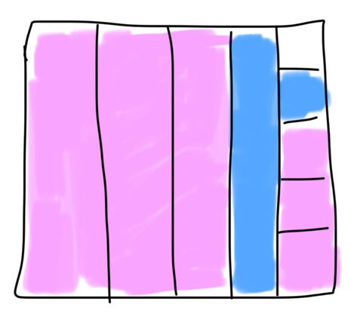
This shows the outer ring of the pattern, in which the total blue area is 6/24 = 1/4. The same will be true for each ring added, therefore a quarter of the overall pattern is blue.

The sequence of fractions whose sum represents the blue area is a geometric sequence with a = 6/25 and r = 1/25. So the sum to infinity = (6/25)/(1-1/25) = 1/4.

