TRIANGLE TRANSFORMATION

Question: Can you find a way to cut your triangle into no more than four pieces, and reassemble the pieces to make a rectangle?

These are the triangles I am working with. The lines inside the triangles are the places you should cut.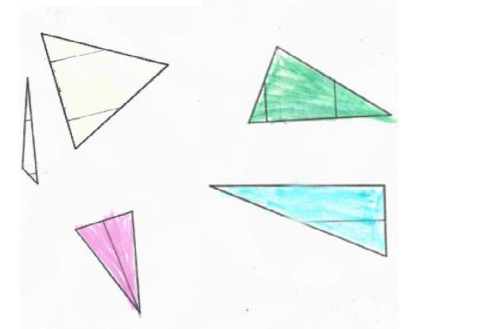

These are the triangles rearranged; as you can see these rectangles used to be triangles.
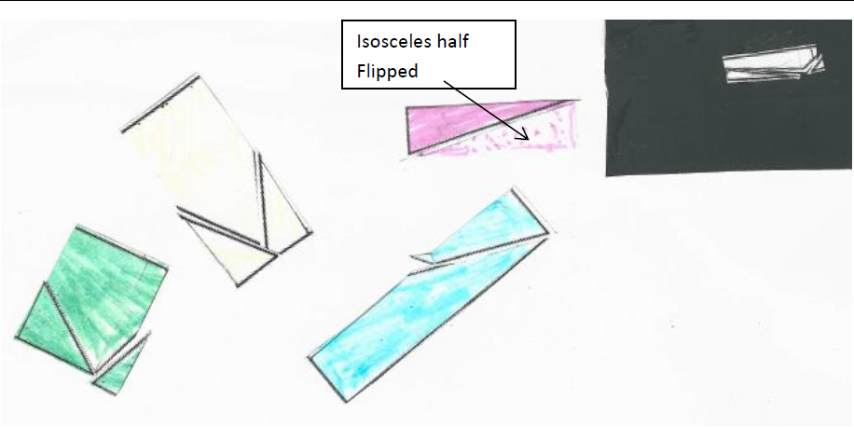

Answer to Question: Out of all the Triangles I have worked with, you can always make a rectangle by cutting them less than 4 times.

