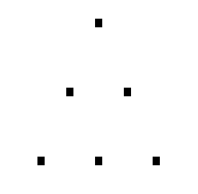
A >

B>

C>

A is 1 B is 2 C is 3 D is 4 E is 5 F is 6 G is 7 H is 8 I is 9 J is 10

1+2+3+4+5+6+7+8+9+10=55
Letter | Number of bricks this letter | Total number of bricks so far
A | 1 | 1
B | 2 | 3
C | 3 | 6
D | 4 | 10
E | 5 | 15
F | 6 | 21
G | 7 | 28
H | 8 | 36
I | 9 | 45
J | 10 | 55

See the pattern?

