Number Jumbler Solution!
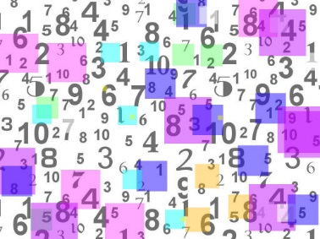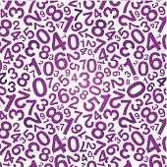
- First, we found our answer in the chart and memorised our symbol. Then we clicked on the number jumbler machine and it guessed our symbol. Then we repeated the process. We noticed that the symbols number digit sum was 9. We then tried all the numbers in the sixties 60 61, 62, 63, 64, 65, 66, 67, 68, 69. Each time we got the answer 54. Each time it guessed our symbol but when we did the number 69, we looked at the other numbers with the same symbol as the number 54. We noticed that each number with the same symbol as 54 all had the digit sum of 9. With this important piece of information, we were able to predict what the symbol would be. In conclusion, the machine always guesses your number because no matter what number on the chart you use you will always end up with a number that has the digit sum of 9.
By Ava Burlison and Katie Labadie!

