Weather Forecasting and Chaos Theory
Vilhelm Bjerknes^{[1]} was one of the first mathematicians to consider the possibility of using mathematics in weather forecasting, in the late 19th century. It is now used globally as a tool for meteorologists, especially in computer algorithms, as there is too much data for a single human to process. Supercomputers^{[2]} are used to collect and observe data involving temperature, pressure, wind, tides, etc. which allow weather prediction models to then be formed from this. This is still not necessarily 100% accurate because of the theory of chaotic behaviour. Edward Lorenz, who discovered the atmosphere is chaotic, stated that it was actually impossible to forecast accurately for a duration of more than two weeks, as even a small error in initial conditions could create a whole new simulation. Modern forecasting models use a process called ensemble forecasting where the simulation is run several times each time with slightly different initial conditions and then averaged to find the most likely forecast. This can be done by constructing a grid to divide the atmosphere up. There are several different versions of this grid however in doing so the atmosphere can be discretized, meaning researchers can get a finite number of quantitative values that can then be used in calculations over qualitative data that is much more difficult to interpret.
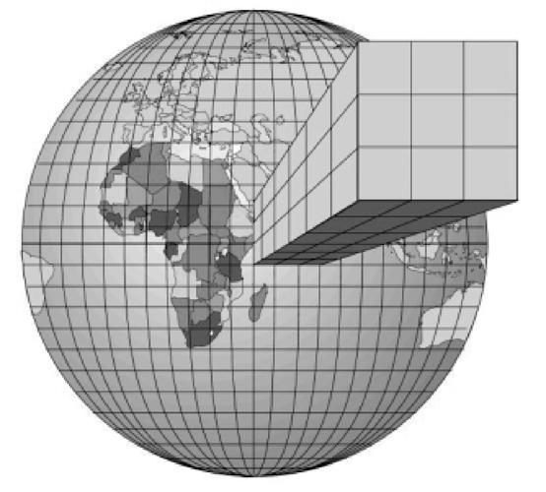
Figure 1: Depiction of Grid-Based System

[1] Eminger S. The History of Weather Forecasting. Available from : https://mathshistory.st-andrews.ac.uk/HistTopics/Weather_forecasts/#3.1 [Accessed 2nd February 2021].
[2] NOAA Headquarters. The mathematics of weather prediction. Available from : https://phys.org/news/2016-05-mathematics-weather.html [Accessed 2nd February 2021].
Saanya Verma

