The first thing I was curious about was the bound for the value of r so that the map did not go negative. To investigate this, I looked at the cobweb diagram. 2 points were noticed:
- The function is positive when 0 < x < 1. This means that whenever x is within these bounds, f(x) would always be positive.
- When the cobwebs converged onto a single point, the point seemed to be where the line y = x met f(x).
To see the values for r for which f(x) was positive, I had the condition:
$$0 ≤f\left(x\right)≤1$$
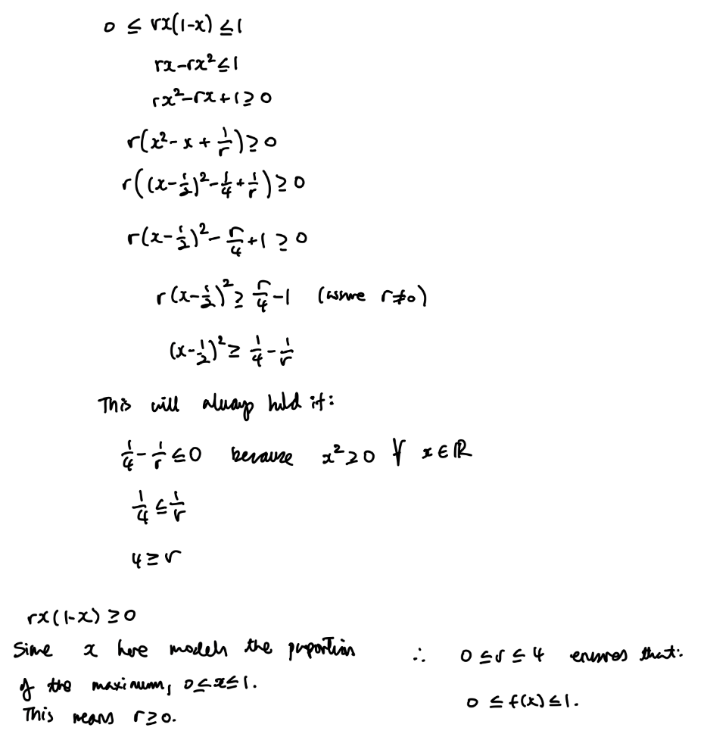
As I write this up it occurs to me that this is saying that because of modelling the population as a ratio, the condition 0 < x < 1 must kick in. Since the input of the next iteration is output of the previous iteration, bounds must be placed on the growth rate for the model to make sense. However, this seems a bit strange to me as I do not know why simply changing how the input variable is inputted results in bounds on the growth rate which is a meaningful variable in this context. A question to further ponder.
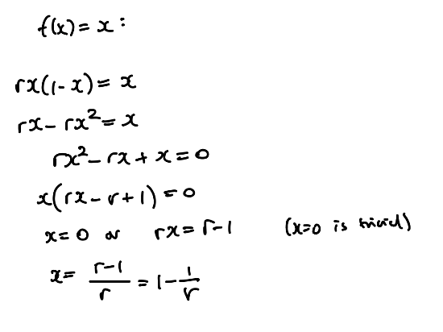
As wells as this, I explored observation 2, which lead to the conclusion that when x = (r-1)/(r), the equation spits out x again (shown below).
This is effectively an oscillation about 1 point. However, to consider oscillation about n points the equation:
$$f^{n}\left(x\right)=x$$
Would need to be solved. This is equivalent to saying what value of x would equal the value found when f(x) is applied n times to x.

